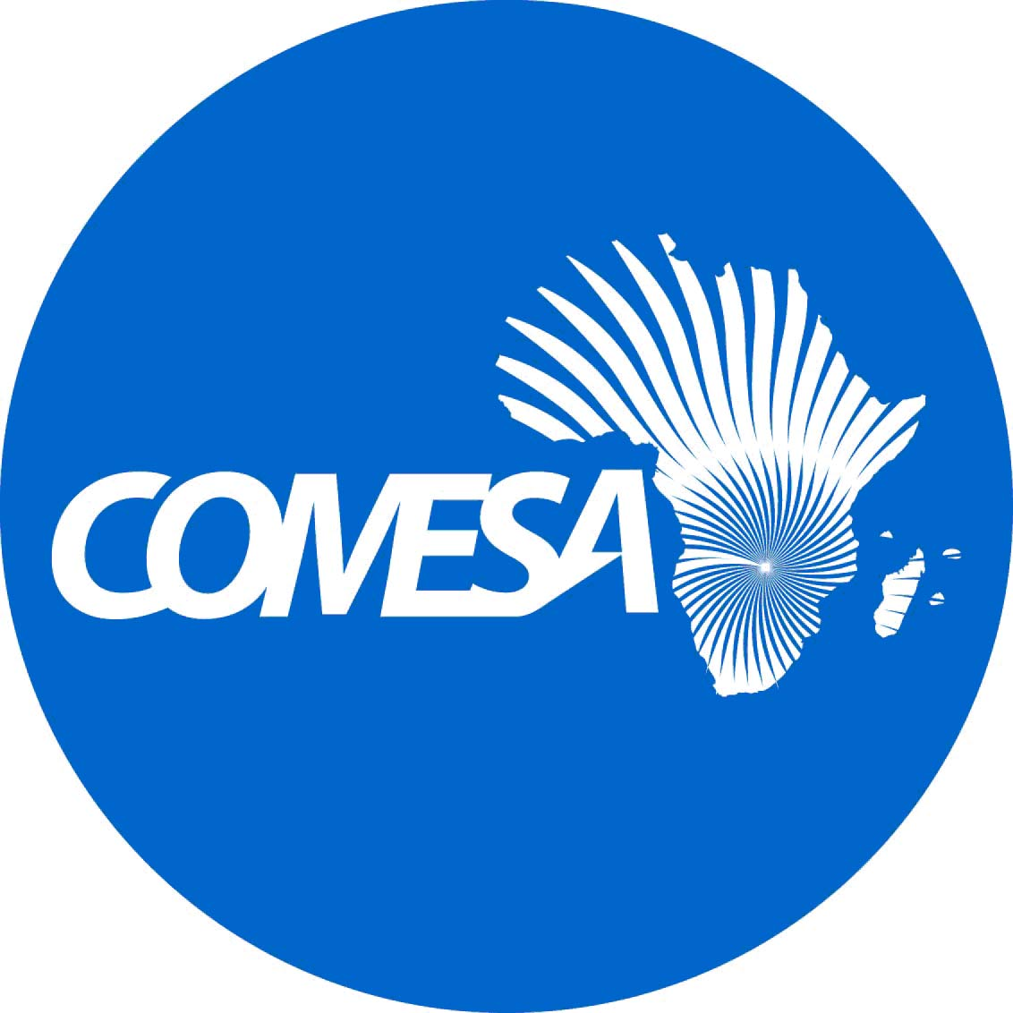

STATEMENT BY THE COMESA Secretary General
DURING the opening CEREMONY of the 42ND meeting of THE COUNCIL OF MINISTERS

CONDUCTED VIA VIDEO CONFERENCING
09 NOVEMBER 2021

Our Guest of Honour, Her Honour the Vice President of the Republic of Zambia Mrs. Mutale Nalumango;
Chairperson of the COMESA Council of Ministers;
Honourable Ministers Present Here;
Permanent/Principal Secretaries;
Assistant Secretaries General in charge of Programmes and Administration and Finance;
Excellencies Permanent Representatives to COMESA;
Excellencies Ambassadors and High Commissioners;
Our Cooperating Partners;
Representatives of International Organizations;
Distinguished Delegates, Observers and Guests;
Officials of the Secretariat;
Heads and Officials of COMESA Institutions;
Ladies and Gentlemen.

Let me start by warmly welcoming you all, Honourable Ministers and all delegations to this Forty Second Meeting of the COMESA Council of Ministers which is our second Virtual Council meeting since the outbreak of Covid-19. We also have among us several dignitaries and partners who have graced our meeting. I warmly welcome you all.

Honourable Ministers, Ladies and Gentlemen,
Since its outbreak in December 2019, the Covid 19 pandemic has spread quickly across the globe, threatening the existence of humanity, global economic integration, value chain supplies and human mobility in general.
Honourable Ministers, Ladies and Gentlemen
The Covid-19 pandemic has proved to us that regional integration can play a critical role in meeting the supply and demand needs of goods and services in our region. The Secretariat has undertaken a study which has shown a huge export trade potential of US$ 101.1 billion using 2019 Trade Statistics. We need to promote sourcing of available products from within our region to promote regional trade and development.

Honourable Ministers, Ladies and Gentlemen,
Some of these obstacles could be overcome through enhancing our productive capacities, strengthening market information on availability of quality products within the region, establishing tailor-made production lines for products that are demanded by other COMESA Member States, reviving the COMESA Trade Fairs, enhancing dissemination of market information and developing a trade information system/catalogue of products produced within the region among others.

Honourable Ministers, Ladies and Gentlemen,
Allow me to take this opportunity to highlight some of the key achievements in our programmes; In the area of market integration, with support from development partners, the European Union and the World Bank, and our Institutions, several Trade Facilitation Programmes are at various stages of implementation.

Honourable Ministers, Ladies and Gentlemen,

Regarding trade in services, it is worth noting that Member States negotiated and made commitments in the four prioritized sectors, namely Tourism & Travel, Transport Services, Communication Services and Financial Services sector. Member States have also commenced negotiations in phase two which involves business, energy, and construction and engineering related services.

Honourable Ministers, Ladies and Gentlemen,
COMESA’s major goal as an organisation, is to improve the living conditions of our people. We therefore take a developmental approach to regional integration, with a focus on Trade and Investment, Industrialization, and Infrastructure, while taking cognizance of all relevant enablers for social economic transformation.

Furthermore, We therefore take great pride in our COMESA Virtual Masters’ degree programme in regional integration, a first in Africa. To date we have students learning in two Universities; our policy research program is vibrant, and we can offer timely responses to emerging issues. The latest Annual Research Forum was held virtually in September 2021 under the theme “Rethinking Doing Business and Trade in the Wake of Covid-19”. Brilliant innovation ideas were also showcased during the forum by a blend of young and seasoned innovators from our region

In addition, our Institutions continue to be leading institutions of excellence in Africa; our online NTB reporting, monitoring and elimination is able to speedily address non-tariff barriers; and the highly technical and professional character of our Secretariat, which we believe is one of our distinguishing features.

Honourable Ministers, Ladies and Gentlemen,
The infrastructure programme has been aligned with continental efforts through a holistic and corridor-based approach to infrastructure development based on three key pillars: policy and regulatory harmonization, development of priority regional physical infrastructure and institutional connectivity.
Honourable Ministers, Ladies and Gentlemen,
The 4th Meeting of the Committee of Ministers of Industry held in May 2021 considered and adopted sectoral frameworks to drive the industrialization agenda of the region premised on the COMESA Industrial Strategy namely;
Honourable Ministers, Ladies and Gentlemen,
We organized the first-ever meeting of COMESA Ministers of Youth Affairs in June 2021 which approved a framework to assist Member States develop annual reports on youth engagement, participation, and policies. The Ministers also adopted the COMESA Youth Engagement Strategy and the Terms of Reference for the establishment of the COMESA Youth Advisory Panel. In addition, the 50 Million African Women Speak platform has been launched in most of the countries in our region, EAC and ECOWAS.

Honourable Ministers, Ladies and Gentlemen,
As you are aware, COMESA concluded implementation of 2016 - 2020 medium-term strategy and has developed a draft successor strategy for the period 2021-2025. The Draft strategy has been carefully designed to map the way forward for COMESA’s integration agenda having taken into consideration key achievements, lessons learnt and challenges of the previous strategy.

The new Strategy aims at transforming the region through focusing on the following strategic pillars; Market Integration, Physical Integration/Connectivity, Productive Integration and Gender and Social Integration. The pillars support COMESA’s mission to facilitate the achievement of sustainable economic and social progress in Member States through increased co-operation and integration.

The 2021-2025 MTSP is part of your agenda today and it will be presented for your consideration and adoption.

Honourable Ministers, Ladies and Gentlemen,
The continental impetus to deeper and broader integration is irreversible, as demonstrated by several flagship programmes that have taken off, particularly the African Continental Free Trade Area and the Single African Air Transport Market, among others. As a strong Regional Economic Community, COMESA continues to set benchmarks, provide good practices, and proactively support the African continental integration process.

Trading under the AfCFTA Agreement commenced on 1st January 2021 and the AfCFTA will benefit us in at least five mutually reinforcing ways: it’s a much larger market whose free flow of goods and services will help to maintain and spur economic growth, will serve as an impetus for investment in our cross-border infrastructure, the prospects for the larger markets and supporting infrastructure will spur industrial development, the signal of larger markets will help to stimulate trade in services. The AfCFTA will also address the problem of multiple memberships in various economic blocs.

Honourable Ministers, Ladies and Gentlemen,
The COMESA-EAC-SADC Tripartite Free Trade Area also continues to register good progress. Though slow, the ratifications continue to come in, and so far, we have eleven member/partner States that have ratified the Agreement. We only need three more ratifications for the agreement to enter into force. I urge those Member States who have not yet done so, to rise to the occasion and ensure that all Member States complete the ratification process of the Tripartite Free Trade Area.

Honourable Ministers, Ladies and Gentlemen,
To strengthen the capacity of the Secretariat, Honourable Ministers will be invited to approve recruitment of new staff members, including two key Directors, and to renew contracts for various staff members. We also thank you for your continued support of the Secretariat through Membership annual assessed contributions and I appeal to all who have not yet done so, to remit the 2021 assessed contributions and arrears to facilitate the smooth operations of your Secretariat.

Honourable Ministers, Ladies and Gentlemen,
The agenda before you is heavy and contains the Reports of various Sectoral Ministerial Meetings for your consideration. These include the Reports of Meetings of Ministers responsible for Transport, Information and Communication Technology and Energy; the first Meeting of Ministers Responsible for Youth Affairs; Meeting of the Ministers Responsible for Gender and Women’s Affairs, Meeting of Ministerial Committee on Industry and the Meeting of the Ministers of Justice and Attorneys General. In addition, the meeting will consider the Report of the 42nd Meeting of the Inter-Governmental Committee.

Honourable Ministers, Ladies and Gentlemen,
As I conclude, despite the Covid-19 disruptions, we have made some solid achievements and we can look to the future with great optimism and determination. The COMESA we want is within our power to achieve and reap the benefits of regional integration. It will only require working together as a team, supported by competent and adequate capacity at the Secretariat and in the Member States. We must also put all effort to support and sustain our own institutions and programmes as first responders where need arises, to ensure we position our ourselves as significant players and contributors in critical sectors such as agriculture and women empowerment which will be under consideration. I wish you fruitful deliberations and look forward to your candid decisions and positive outcomes which will deepen and strengthen our regional integration agenda. I thank you for your attention.

