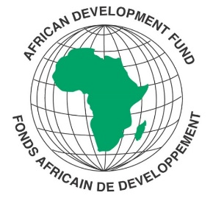
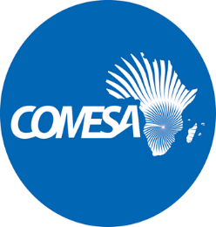

REQUEST FOR EXPRESSIONS OF INTEREST

SELECTION OF TWO INDIVIDUAL CONSULTANTS

REFERENCE NUMBER: CS/SCBV/22/5/dm

REQUEST FOR SERVICES TITLE: TWO (ONE FRANCOPHONE & THE OTHER ANGLOPHONE) INDIVIDUAL CONSULTANCY FOR THE DEVELOPMENT OF CIVIL REGISTRATION AND VITAL STATISTICS (CRVS) STRATEGIC PLANS

STATISTICAL CAPACITY BUILDING PROGRAM, PHASE V
COUNTRY: MULTINATIONAL
Financing Agreement reference: 2100155040967
Project ID No.: P-Z1-K00-099

The Common Market for Eastern and Southern Africa (COMESA) has received financing from the African Development Fund in the form of a “financing” toward the cost of implementation of the Statistical Capacity Building Program, Phase V (SCB V). The Common Market for Eastern and Southern Africa (COMESA) intends to apply a portion of the agreed amount for this grant to eligible consultants to undertake different assignments under the SCB V.

The project is implemented in all African Development Fund (ADF) eligible Member states, Regional Economic Communities and Statistical Training Centers. The SCB program is the fifth (SCB-5) of ADF funded cycles for strengthening statistical capacity in Africa and is anchored on many years of accumulated practical experience and incremental value addition to the African Statistical System. The SCB-5 will be crucial for maintaining the momentum built on past gains whilst shielding against possible reversal of the gains made across the continent in recent years. The program will focus on the following components: Improving the availability and quality of economic statistics, including the measurement of the COVID-19 impact, Improving the quality and availability of Social Statistics and reporting on COVID-19, Data Collection, Management and Dissemination and Strategic Planning, Systems Development, Coordination and Training.
The Common market for Eastern and Southern Africa (COMESA) Secretariat now invites eligible candidates to apply for the consultancy assignment on the Development of Civil Registration and Vital Statistics (CRVS) Strategic Plans.

Eligibility criteria, and the selection procedure shall be in accordance with the African Development Bank’s “Procurement Policy for the Bank Group-funded Operations”, dated October 2015, which is available on the Bank’s website at http://www.afdb.org.

Detailed description of the assignment including the Terms of Reference defining the minimum technical requirements for these services are provided in the Request for Expression of Interest document which can be downloaded free of charge from the COMESA website on the link alongside this notice: www.comesa.int

Additional requests for information and clarifications can be made until 7 working days prior to deadline at the following addresses:

E-mail: DMaimbo@comesa.int; smwesigwa@comesa.int; procurement@comesa.int;

SUBMISSION OF APPLICATIONS

Your application documents clearly marked and email bearing the subject,

“INDIVIDUAL CONSULTANCY FOR THE DEVELOPMENT OF CIVIL REGISTRATION AND VITAL STATISTICS (CRVS) STRATEGIC PLANS”.

should be emailed to the following address:

statistics@comesa.int

Physical submission of applications is NOT allowed.

The deadline for submission of your application to the submission address indicated above is:

27 APRIL 2022 AT 16:00 hours

