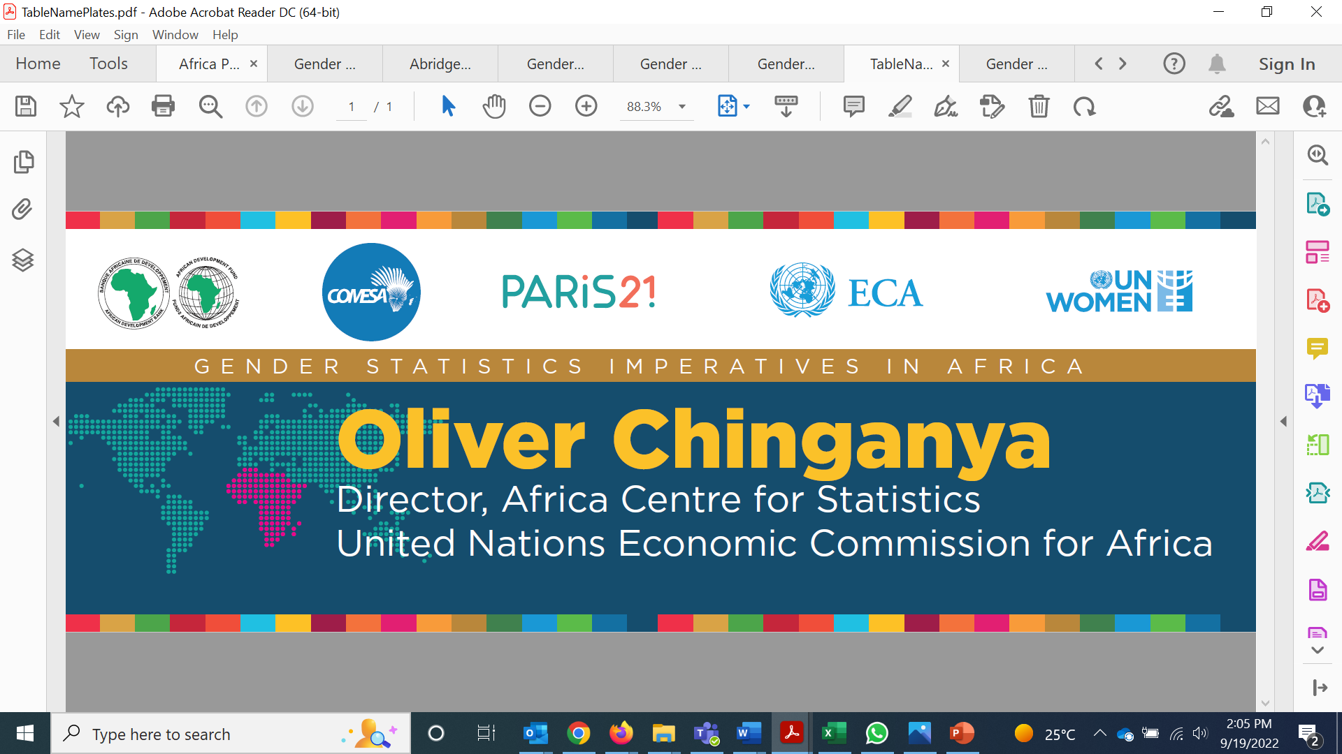



FOR IMMEDIATE RELEASE
Data on Women and Girls Takes Centre Stage as Representatives from 40 African Countries Convene in Nairobi for the Joint Africa Gender Statistics Conference
Nairobi, 26 September 2022—Today, more than 150 public and civil society actors from 40 African countries convened in Nairobi, Kenya for the Joint Africa Gender Statistics Conference taking place from 26 -30 September 2022.
Held under the theme ‘Gender Statistics Imperatives for Africa’, the Conference will interrogate gender statistics through the lens of Agenda 2063—the African Union’s blueprint for transforming Africa into a global powerhouse, the Sustainable Development Goals that support gender equality and women’s empowerment, and global guidance on violence against women data, among others.
Delegates comprising policy analysts and gender statistics experts from line ministries, national statistical offices, and civil society will exchange knowledge on the latest innovations and best practices in gender statistics to inform action plans in AU member states and the region as a whole.
Gender statistics are instrumental in measuring progress towards achieving regional and global gender development goals. However, the production of gender statistics is relatively new, and information is not fully consolidated and always readily available, even at the global level.
”Gender equality has increasingly been recognized as being essential to the process of sustainable development and the formulation of effective national development policies and programmes,” said Themba Munalula, Chief Statistician, Common Market for Eastern and Southern Africa (COMESA).
“Given the pivotal role of gender equality in socioeconomic and cultural development, ensuring that African countries produce high-quality, timely, and reliable gender data has far-reaching benefits,” said Roza Mamuye Bora, Principal Statistician at the African Development Bank Group (AfDB).
The production of gender statistics in the region has been slow due to a combination of factors including a reluctance to change how statistics have traditionally been compiled and presented, lack of knowledge on how change can be effected, and a constrained policy and financial environment.
“Gender data and statistics are not just important for their own sake. The end goal is really to improve the lives of women and girls as envisioned by the SDGs and other regional and international plans,” said Dr. Maxime Houinato, UN Women East and Southern Africa Regional Director.
“While nearly all countries in the region have endorsed the SDGs and incorporated them into national strategies and plans, lack of funding is often cited as the most critical impediment in the region”, said Houinato.
“This has hindered the progress of national statistical offices in designing the systems and operations needed to generate gender data for evidence-based policymaking and advocacy,” said Fatouma Sissoko, Gender Statistician at the United Nations Economic Commission for Africa (ECA).
Despite these challenges, regional initiatives such as the Africa Programme on Gender Statistics (APGS), have contributed significantly to improvements in gender statistics at both the regional and national level. An umbrella regional programme implemented by regional organizations, regional economic communities, civil society organizations, and international agencies, the APGS is currently in its third phase (APGS III). The Programme has made strides in improving the availability of accurate and standardized gender statistics by developing methodologies and approaches for the production of gender statistics in Africa.
However, much remains to be done in terms of improving coordination and reinforcing partnerships to strengthen knowledge, skills, and communication related to the production, dissemination, and use of gender statistics in the region. This is one of the main focus areas of APGS III, which is also being launched during the Joint Africa Gender Statistics Conference.

For more information, please contact:

AfDB  Koffi Marc Kouakou  Statistician Economist  Gender, Women and Civil Society  m.koffi@afdb.org | COMESA  Themba Munalula  Chief Statistician and Head,  Statistics Department  TMunalula@comesa.int | Paris21 (hosted in OECD's Statistics and Data Directorate)  Lauren Harrison Desai  Policy Analyst, Data Ecosystems Lead  Statistics and Data Directorate  Organisation for Economic Co-operation and Development Lauren.HARRISON@oecd.org

UNECA  Fatouma Sissoko  Gender Statistician  African Centre for Statistics <sissokof@un.org> | UN Women (East & Southern Africa)  Isabella Schmidt  Regional Gender Statistics Specialist  East and Southern Africa  Isabella.Schmidt@unwomen.org | UN Women (West & Central Africa)  Michele Serrousi  Regional Gender Statistics Specialist  West and Central Africa  Michele.Serrousi@unwomen.org

