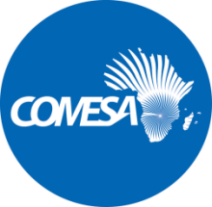
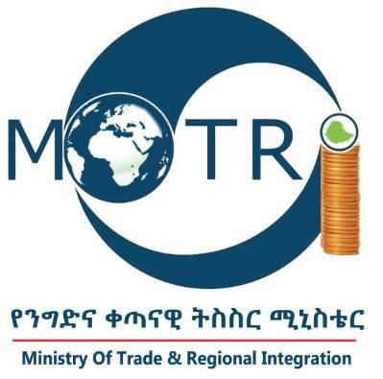

VACANCY ANNOUNCEMENT

Ref. No.: MoTRI/PROC/EDF11/002/2022TFP

Ministry of Trade and Regional Integration

CALL FOR APPLICATIONS: Senior Trade Expert as a short-term Consultant to facilitate the COMESA and AfCFTA trade integration process

The Ministry of trade and Regional Integration (MoTRI) in collaboration with the COMESA Secretariat is implementing a Trade Facilitation Programme funded under the COMESA EDF 11 - Trade Facilitation Programme. As part of the project implementation, the MoTRI is inviting individual Consultants to submit their CVs and Financial Proposals for the following services:
Senior Trade Expert (STE Consultant) to Support the Ministry of Trade and Regional Integration (MoTRI) in Facilitating the COMESA FTA and AFCFTA Trade Integration Process – Funded under the COMESA EDF 11 Trade Facilitation Programme (TFP).

Applications are invited from suitably qualified and experienced professionals for the position. The Terms of References (ToRs) defining the minimum technical requirements for these services and other information can be obtained from the Ministry of Trade and Regional Integration website on https://motri.gov.et/en/vacancies:

https://motri.gov.et/sites/default/files/vacancy/REOI_and_ToRs_Document_for_Senior_TRADE_Expert_STE_Consultant_to_0.pdf

