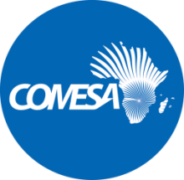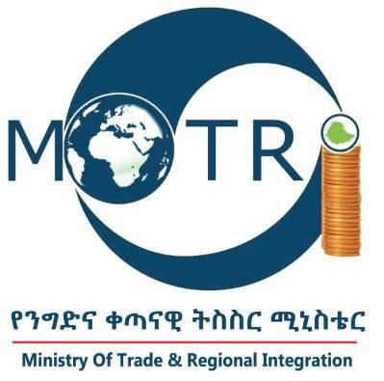

VACANCY ANNOUNCEMENT
(RE-ADVERTISED)

Ref. No.: MoTRI/PROC/EDF11/001/2021TFP

Ministry of Trade and Regional Integration

CALL FOR APPLICATIONS: SHORT-TERM EXPERT (STE) Consultant - National Project Coordinator to Assist in Implementation of Upgrade Ethiopia’s Galafi and Moyale Border Posts Project Funded under the COMESA EDF 11 –TFP

The Ministry of trade and Regional Integration (MoTRI) in collaboration with the COMESA Secretariat is implementing a Trade Facilitation Programme funded under the COMESA EDF 11 - Trade Facilitation Programme. As part of the project implementation, the MoTRI is inviting individual Consultants to submit their CVs and Financial Proposals for the following services:
Short-Term Expert (STE) Consultant - National Project Coordinator to Assist in Implementation of Upgrade Ethiopia’s Galafi and Moyale Border Posts Project Funded Under the COMESA EDF 11 -TFP.

Applications are invited from suitably qualified and experienced professionals for the position. The Terms of References (ToRs) defining the minimum technical requirements for these services and other information can be obtained from the Ministry of Trade and Regional Integration website on https://motri.gov.et/en/vacancies;

https://motri.gov.et/sites/default/files/vacancy/Re_advert_REOI_TOR_Document_for_STE_National_Project_Coordinator.pdf

