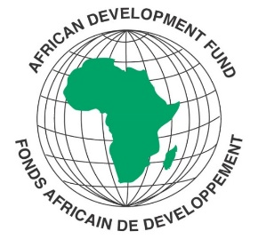
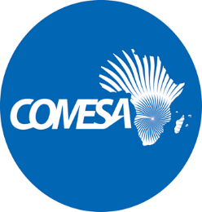

SPECIFIC PROCUREMENT NOTICE

SELECTION OF INDIVIDUAL CONSULTANT

REFERENCE NUMBER: CS/IAD/RPHS/F1

REQUEST FOR SERVICES TITLE: FINANCIAL SPECIALIST/ACCOUNTANT FOR THE COMESA SUPPORT TOWARDS REGIONAL PHARMACEUTICAL SECTOR DEVELOPMENT (CSTRPSD)

COMESA SUPPORT TOWARDS REGIONAL PHARMACEUTICAL SECTOR DEVELOPMENT (CSTRPSD)
COUNTRY: MULTINATIONAL
Financing Agreement reference: 2100155042033
Project ID No.: P-Z1-BB0-008

The COMESA Secretariat has received financing from the African Development Fund toward the cost of the COMESA Support Towards Regional Pharmaceutical Sector Development (CSTRPSD or the Project) and intends to apply part of the agreed amount for this grant to payments under the contract for the services of a Financial Specialist/Accountant for the CSTRPSD Project.

The pharmaceutical industry in the region is nascent and characterised by limited technical capacity to locally manufacture enough essential medicines and medical supplies to meet domestic demand. This is due to several challenges faced by the sector, including weak national regulatory institutions, poor quality control systems, lack of credible and certified laboratories, among others.The objectives of this Project , therefore, are to provide institutional support for the development of the pharmaceutical industry through strengthened capacities of the region’s pharmaceutical regulatory bodies, quality control and management systems, research, and development institutions for effective manufacturing of safe and quality pharmaceutical products in the region.

The services included under this project are providing financial and accounting services relating to processing and recording of financial transactions and financial reporting for the CSTRPSD Project. The estimated period of execution is three (3) years with a possibility of extension subject to availability of funds for continued project implementation and satisfactory performance. The initial contract period shall include a six (6) months probationary period.

The COMESA Secretariat now invites eligible consultants to indicate their interest in providing these services. Interested consultants must provide information indicating that they are qualified to perform the services. The Expression of Interest shall be evaluated as follows:

 | Criteria | Maximum points allocated
1 | Education qualifications | 35
2 | Professional Skills and Experience for the position | 50
3 | Experience in the region | 10
4 | Language proficiency | 5
 | Total | 100

Eligibility criteria, and the selection procedure shall be in accordance with the African Development Bank’s Procurement Policy and Methodology for Bank Group Funded Operations”, dated October 2015, which is available on the Bank’s website at http://www.afdb.org.

Detailed description of the assignment including the Terms of Reference defining the minimum technical requirements for these services are provided in the Request for Expression of Interest document which can be downloaded free of charge from the COMESA website on the link alongside this notice: www.comesa.int .

Additional requests for information and clarifications can be made until 3 working days prior to deadline at the following addresses:

E-mail: s.mwesigwa@comesa.int; procurement@comesa.int;

SUBMISSION OF APPLICATIONS

The Expression of Interest which must be submitted using the Expression of Interest Forms attached as Annex 2 to the Request for Expression of Interest document and clearly marked and email bearing the subject,

“INDIVIDUAL CONSULTANCY: CS/IAD/RPHS/1 - PROVISION OF CONSULTANCY SERVICES OF FINANCIAL SPECIALIST/ACCOUNTANT FOR THE COMESA SUPPORT TOWARDS REGIONAL PHARMACEUTICAL SECTOR DEVELOPMENT (CSTRPSD)

should be emailed to the following address:

s.mwesigwa@comesa.int

Physical submission of applications is NOT allowed.

The deadline for submission of your application to the submission address indicated above is: 27 March, 2023 at 16:00 hours

