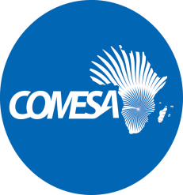
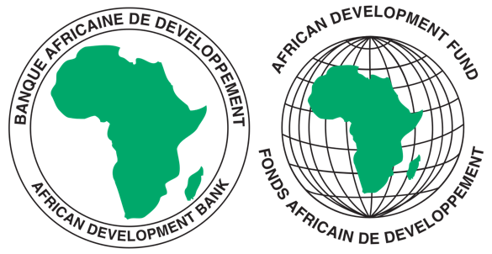

REQUEST FOR EXPRESSIONS OF INTEREST
(CONSULTING SERVICES - FIRM)

COMMON MARKET FOR EASTERN AND SOUTHERN AFRICA
PROJECT ON REGIONAL HARMONIZATION OF REGULATORY FRAMEWORKS AND TOOLS FOR IMPROVED ELECTRICITY REGULATION IN COMESA

Sector: Energy
Financing Agreement reference: 2100155041058
Project ID No.: P-Z1-FA0-186

The Common Market for Eastern and Southern Africa (COMESA) has received financing from the African Development Fund toward the cost of the Project on Regional Harmonization of Regulatory Frameworks and Tools for Improved Electricity Regulation in COMESA and intends to apply part of the agreed amount for this grant to payments under the contract for “Consulting Services for Regional Harmonization of Regulatory Frameworks and Tools for Improved Electricity Regulation in COMESA”.
The services included under this project involve carrying out the following:
- Elaboration of regional electricity regulatory principles (RERP) and regulatory key performance indicators (KPI);
- Definition of utility key performance indicators (UKPI) for measuring performance targets; and
- Development of a framework for harmonised comparison of electricity tariffs (HCET) and cost reflectivity assessment for the COMESA region.
As part of this consultancy assignment, the consultant is expected to develop guiding frameworks on electricity regulatory principles, practices, and key performance indicators (KPIs) for adoption. Another objective is to elaborate and implement a standardized comparative dataset of KPIs that can be utilized to assess and monitor the performance of utilities, while also facilitating incentive-based regulation across the same region.
Moreover, the assignment will involve the development of a framework that will enable COMESA to track the progress of migration towards cost-reflective electricity tariffs, as well as to harmonize comparison of the tariffs. It is expected that the period of implementation of this consultancy assignment will not exceed six months.
The Common Market for Eastern and Southern Africa now invites eligible consulting firms to indicate their interest in providing these services. Interested consultants must provide information indicating that they are qualified to perform the services (brochures, description of similar assignments, experience in similar conditions, availability of appropriate skills among staff, etc.). Consultants may constitute joint ventures to enhance their chances of qualification.

Eligibility criteria, establishment of the short-list and the selection procedure shall be in accordance with the Procurement Policy and Methodology for Bank Group Funded Operations, dated October 2015, which is available on the Bank’s website at http://www.afdb.org.

Interested consultants may obtain further information by sending email with requests for clarification during office hours, 0800 - 1700 hours Central Africa Time (CAT). The email should be addressed to the following email address: Procurement@comesa.int.

Expressions of interest must be delivered to the email address below by 31st May 2023 at 1600 hours CAT and mention “Consultancy Services for Regional Harmonization of Regulatory Frameworks and Tools for Improved Electricity Regulation in COMESA”.

Attn:
Mr. Silver Mwesigwa
Head of Procurement
Common Market for Eastern and Southern Africa (COMESA)
Ben Bella Road
P O Box 30051
Lusaka, Zambia
Tel: 260 211 229725–32
Email: tenders@comesa.int

NB: Physical submission of EOIs will not be accepted.

