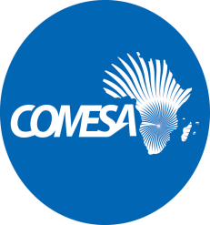
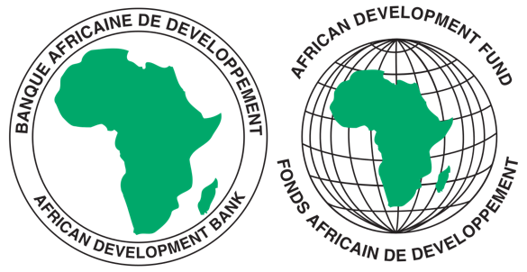

REQUEST FOR EXPRESSIONS OF INTEREST
(CONSULTING SERVICES - FIRM)

COMMON MARKET FOR EASTERN AND SOUTHERN AFRICA
PROJECT ON REGIONAL HARMONIZATION OF REGULATORY FRAMEWORKS AND TOOLS FOR IMPROVED ELECTRICITY REGULATION IN COMESA

Sector: Energy
Financing Agreement reference: 2100155041058
Project ID No.: P-Z1-FA0-186
The Common Market for Eastern and Southern Africa (COMESA) has received financing from the African Development Fund toward the cost of the Project on Regional Harmonization of Regulatory Frameworks and Tools for Improved Electricity Regulation in COMESA and intends to apply part of the agreed amount for this grant to payments under the contract for “Consultancy Service for Development of an Information Management System for RAERESA”.
The services included under this project involve carrying out the following:
- Conduct a needs assessment exercise and develop system specifications for the IMS;
- Design, develop, and deploy an information management system for RAERESA; and
- Conduct technical and user training for stakeholders.
As part of this consultancy assignment, the consultant is expected to assist the Regional Association of Energy Regulators of Eastern and Southern Africa (RAERESA) to bridge the current information gap by developing a robust information and database management system to synchronize and harmonize energy data collection, storage, retrieval, and dissemination among COMESA Countries and globally. The project will among other things establish a centralized information and database system to be hosted at COMESA Secretariat with access to member countries to directly feed into and retrieve information according to pre-defined templates.
It is expected that the period of implementation of this consultancy assignment will not exceed seven months.
The Common Market for Eastern and Southern Africa now invites eligible consulting firms to indicate their interest in providing these services. Interested consultants must provide information indicating that they are qualified to perform the services (brochures, description of similar assignments, experience in similar conditions, availability of appropriate skills among staff, etc.). Consultants may constitute joint ventures to enhance their chances of qualification.

Eligibility criteria, establishment of the short-list and the selection procedure shall be in accordance with the Procurement Policy and Methodology for Bank Group Funded Operations, dated October 2015, which is available on the Bank’s website at http://www.afdb.org.

Interested consultants may obtain further information by sending email with requests for clarification during office hours, 0800 - 1700 hours Central Africa Time (CAT). The email should be addressed to the following email address: Procurement@comesa.int.

Expressions of interest must be delivered to the email address below by 31st May 2023 at 1600 hours CAT and mention “Consultancy Service for Development of an Information Management System for RAERESA”.

Attn:
Mr. Silver Mwesigwa
Head of Procurement
Common Market for Eastern and Southern Africa (COMESA)
Ben Bella Road
P O Box 30051
Lusaka, Zambia.
Tel: 260 211 229725–32
Email: tenders@comesa.int

NB: Physical submission of EOIs will not be accepted.

