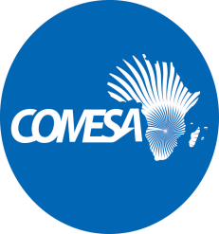
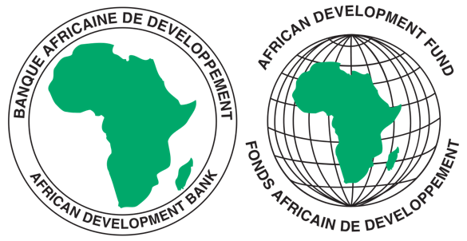
COMMON MARKET FOR EASTERN AND SOUTHERN AFRICA

REQUEST FOR EXPRESSIONS OF INTEREST

SELECTION OF INDIVIDUAL CONSULTANTS

REFERENCE NUMBER: CS/CSTRPSD/05/04/km

CONSULTANCY SERVICES TITLE: CONSULTANCY SERVICES TO SUPPORT THE RE- ESTABLISHMENT AND OPERATIONALISATION OF THE COMESA PHARMACEUTICALS COMMITTEE
PROJECT NAME: COMESA SUPPORT TOWARDS REGIONAL PHARMACEUTICAL
SECTOR DEVELOPMEMNT
SECTOR: INDUSTRIALISATION/PHARMACEUTICAL INDUSTRY
GRANT NUMBER: 2100155042033
PROJECT ID: P-Z1-BB0-008

- This Request for Expression of Interest follows the General Procurement Notice for this Project that appeared in UN Development Business (UNDB online); on the African Development Bank’s Internet Website (www.afdb.org) and the COMESA Secretariat Website (www.comesa.int) on 10 February 2022.

- The COMESA Secretariat has received a grant from the African Development Fund towards the implementation of the COMESA Support Towards Regional Pharmaceutical Sector Development Project. The COMESA Secretariat intends to apply part of the proceeds of the grant to recruit an Individual Consultant to Support the Re-Establishment and Operationalisation of the COMESA Pharmaceuticals Committee.
- The overall objective of the consultancy is to Support the Re-establishment and operationalisation of the COMESA Pharmaceuticals Committee and ensuring its sustainability thereafter.
- Specific objectives of the consultancy are, among other things, to:
- Undertake a detailed analysis of the previous structure and activities of the Pharmaceuticals Committee and update them in line with current trends and developments within COMESA and the continent.
- Engage relevant stakeholders including but not limited to Member States, sister Regional Economic Communities eg EAC, ECOWAS, SADC to inform the revival of the Pharmaceuticals Committee and ensure its sustainability.
- Draft Terms of Reference (ToRs) of the role, responsibilities and functions of the Pharmaceuticals Committee as well as its structure within the COMESA system.

- The COMESA Secretariat now invites eligible candidates to indicate their interest in providing these services. Interested Individual consultants must provide information indicating that they are qualified to perform the services (i.e., description of similar assignments, experience in similar conditions and availability of appropriate skills and qualifications).

- The individual consultants should have significant in-depth expertise and knowledge of pharmaceutical and regulatory initiatives in Africa, experience in organising meetings at the Regional Economic Community (REC) level and demonstrated experience in domesticating continental/regional frameworks in Member States in the COMESA region.

Expressions of Interest shall be evaluated as follows:

- Applicant’s Educational qualifications 30 points
- Relevant Experience and skills 60 points
- Experience in the African Region 10 points

- Eligibility criteria, establishment of the short-list and the selection procedure shall be in accordance with African Development Bank’s “Procurement Framework for Bank Group Funded Operations” dated 2015, which is available on the Bank’s website at: https://www.afdb.org/en/projects-and-operations/procurement/new-procurement-policy. The Consultant will be selected under the Individual Consultant Selection (ICS) method.

- Detailed description of the assignment including Terms of Reference defining the minimum technical requirements for the services can be downloaded free of charge from the COMESA Website on the link alongside this notice: www.comesa.int

- Additional requests for information and clarifications can be made until 5 working days prior to the deadline at the following addresses: E-mail: kmiti@comesa.int; s.mwesigwa@comesa.int; wsiduna@comesa.int

- SUBMISSION OF APPLICATIONS

Expressions of Interest bearing the subject: “Consultancy Services to Support the Re-establishment and Operationalisation of the COMESA Pharmaceuticals Committee” must be submitted using the Expression of Interest Forms annexed to the Terms of Reference and must be emailed to the following addresses: E-mail: kmiti@comesa.int; s.mwesigwa@comesa.int; wsiduna@comesa.int by 8 May 2024

NB: Physical submission of EOIs will not be accepted.

