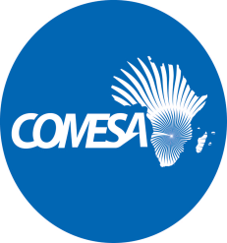
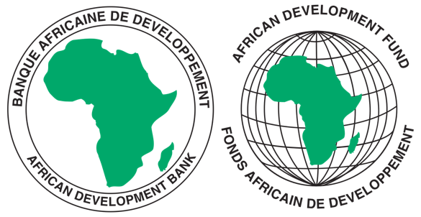

REQUEST FOR EXPRESSIONS OF INTEREST
(CONSULTING SERVICES - FIRM)

COMMON MARKET FOR EASTERN AND SOUTHERN AFRICA

PROJECT NAME: COMESA SUPPORT TOWARDS REGIONAL PHARMACEUTICAL
SECTOR DEVELOPMEMNT
SECTOR: INDUSTRIALISATION/PHARMACEUTICAL INDUSTRY
GRANT NUMBER: 2100155042033
PROJECT ID: P-Z1-BB0-008

- This Request for Expression of Interest follows the General Procurement Notice for this Project that appeared in UN Development Business (UNDB online); on the African Development Bank’s Internet Website (www.afdb.org) and the COMESA Secretariat Website (www.comesa.int) on 10 February 2022.

- The COMESA Secretariat has received a grant from the African Development Fund towards the implementation of the COMESA Support Towards Regional Pharmaceutical Sector Development Project and intends to apply part of the proceeds of the grant to engage a consulting firm to conduct an assessment of (i) Manufacturing Capacity of Pharmaceutical Industry (ii) Pharmaceutical Trade Performance and Supply Chain Integrity in COMESA region, and (iii) the Policy, Regulatory and Institutional Frameworks for Trade in Pharmaceutical inputs and products.

- The objectives of the consultancy are:-
- to assess the capacity constraints in pharmaceutical manufacturing in the COMESA
region.
- to assess the pharmaceutical input and final products trade performance and supply
chain integrity in the COMESA region.
- to assess policy, regulatory and institutional frameworks governing trade in
pharmaceutical products and come up with a model policy for trade facilitation in the
region.

- The COMESA Secretariat now invites eligible consultancy firms to indicate their interest in providing these services. Interested consultants must provide information indicating that they are qualified to perform the services (brochures, description of similar assignments, experience in similar conditions, availability of appropriate skills among staff, etc.). Consultants may constitute joint ventures to enhance their chances of qualification.

- Consulting firm/organization/entity should have professional experience in pharmaceutical manufacturing, regulatory sciences, pharmaceutical policy and trade at regional/continental level or similar experience outside Africa with a demonstrated 20 years of combined experience in delivering similar and relevant assignments in the sector (list of projects’ details including the scope, location, and clients).

- Eligibility criteria, establishment of the short-list and the selection procedure shall be in accordance with African Development Bank’s “Procurement Framework for Bank Group Funded Operations” dated 2015, which is available on the Bank’s website at: https://www.afdb.org/en/projects-and-operations/procurement/new-procurement-policy. The Consulting Firm will be selected under the Quality and Cost Based Selection method.

Interested Consultants can download detailed Terms of Reference from the COMESA Website at: www.comesa.int. Further information, if required, can be obtained by sending email with requests for clarification during office hours, 0800 - 1700 hours Central Africa Time (CAT). The email should be addressed to the following email address: Procurement@comesa.int

- Expressions of interest must be delivered to the email addresses below by 19 July 2024 at 1600 hours CAT and mention “Consultancy Services to assess the Manufacturing Capacity, Pharmaceutical Trade Performance and Policy and Regulatory Framework in the COMESA Region ”.

Attn:
Mr. Silver Mwesigwa
Head of Procurement
Common Market for Eastern and Southern Africa (COMESA)
Ben Bella Road
P O Box 30051
Lusaka, Zambia
Tel: 260 211 229725–32
Emails: s.mwesigwa@comesa.int; kmiti@comesa.int;

NB: Physical submission of EOIs will not be accepted.

