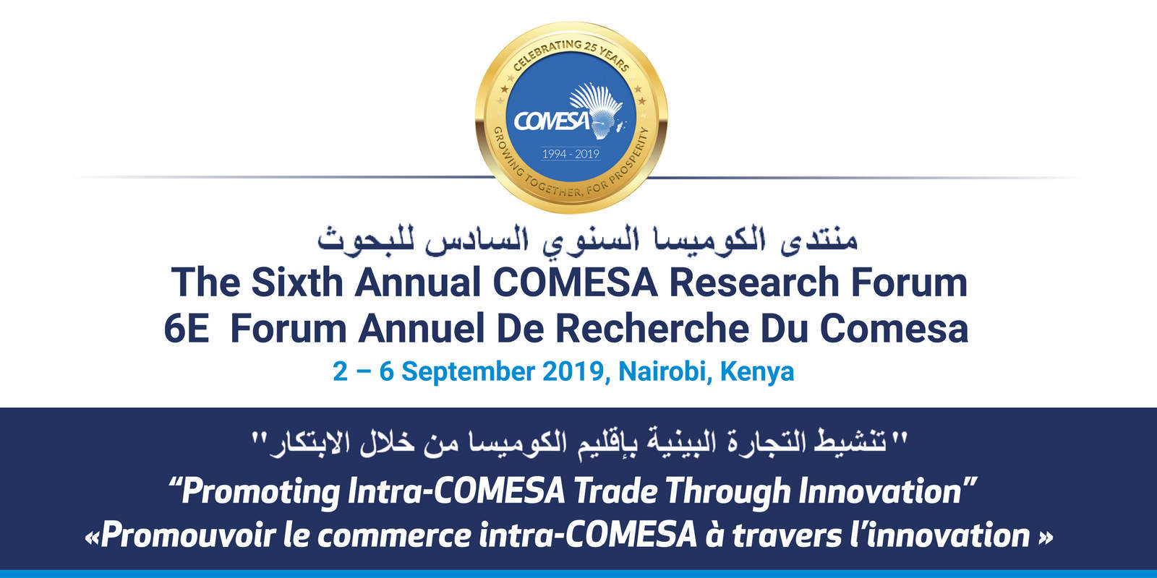

Background

- Since 2014 COMESA has been organizing Annual Research Forums. The main purpose of the research forum is to bring together the academia, think tanks, government officers and the private sector to discuss emerging topical issues in regional integration. This is made possible through call for papers under a contemporary theme which is informed by the COMESA Council of Ministers decisions, the tripartite free trade area or the continental free trade area negotiations and aspirations as well the global economic and trade dynamics.

- The research Forums have been successful, after the call for papers and rigorous internal and external reviews, the final papers are published in the COMESA flagship publication “Key Issues in Regional Integration”. To date, six editions have been published together with the policy briefs of the research papers of the seventh edition. The seventh edition will be ready by mid-September.

- The policy implications from the papers are presented to COMESA policy organs and form the basis for policy decision making. Member States have appreciated the critical role of the trade policy research and analysis and most of them have implemented the policy recommendations from various papers from past research forums. There is therefore ready demand for the research forums’ output.

Sixth COMESA Annual Research Forum

- This year COMESA is organizing the Sixth Annual Research Forum on 02-06 August 2019 in Nairobi, Kenya. The theme for this year’s Annual Research Forum is “Promoting Intra-COMESA Trade through Innovation”. The theme has five sub-themes namely:

- Technology diffusion, absorption and Trade in COMESA;
- Innovation Productivity and its Connection to the Innovation Market in COMESA;
- Role of Intellectual Property Rights in Promoting Investment in Innovation and Trade in COMESA;
- Role of governance in enhancing innovations and trade in COMESA; and
- Innovation and Socio-economic Transformation through Trade in COMESA.
- There is a close link between innovation and trade. Dynamic gains from trade arise from increased competition and the transfer of technology, knowledge, and innovation that trade engenders. In effect, there is a "two-way" link between trade and innovation. On the one hand, innovation creates technological advantage, which (together with differences in factor endowments) is a source of comparative advantage, which in turn drives trade. Therefore, technology gaps have been identified as a key determinant of trade and investment between nations.

- On the other hand, trade and investment also spur innovation through the effects of competition, technology transfer, and spill over (including learning from exporting and learning by investing). Trade that exposes domestic firms to international markets and forces them to compete against sophisticated global competitors is a strong driver of innovation and productivity growth. In fact, data from the OECD Innovation Microdata Project show that exposure to international markets has a strong positive effect either on firms' incentives or their ability to innovate.

- The solid drive for local innovation in Africa has attracted several global firms and tech hubs. These tech hubs could be anything from incubators, co-working spaces, makerspaces, accelerators to mention but a few. Based on the 2016 research carried out by GSMA Ecosystem Accelerator on the rise of tech hubs in Africa, Africa realized up to 314 active tech hubs as compared to the 120 tech hubs listed in the World Bank Report in September 2015. These tech hubs provide space and a platform for the locals to exercise their creativity and develop various solutions.

- Making up a third of Africa, the vastness of COMESA should be complemented with its dynamism and high trade growth. Intra-COMESA export of goods has risen from $1.5 Billion in 2000 to about $8 Billion in 2017, excluding small scale (informal) trade estimated by UNCTAD and ECA at about 40% of total trade. These figures are still not impressive in absolute terms, but the growth is remarkable. What is even more remarkable is the potential as well as the possibility of introducing wholly new products and industries through innovation.

- The growth in intra-COMESA trade remains low compared to the region’s trade with the rest of the world both in terms of exports and imports. The intra-COMESA exports only account for 6.4 percent of region’s total exports compared to about 20 percent for East African Community (EAC) and 62 percent for the EU (UNCTADSTAT, 2015).

- This year’s submission of extended abstracts closed on 15 March 2019 and we received 33 extended abstracts/full papers. This were reviewed and 19 selected to submit full papers by 30 May 2019. The list of all the submitted papers is attached as an annex.

- On the side-lines of the research forum there will be exhibitions of innovations and the innovators will present their innovations for one day plenary sessions. The Research Forum brings together Government Officers, Policy Think Tanks, Academia, Development Partners and the Private Sector.

Show-casing of innovative, incubated and commercialized ideas
- Innovators from COMESA Member States will show case their innovation on the margins of the research forum. The focus will be on new products, new methods of production and new ways of improving technology. Also included in the criteria is methodology of opening new markets, new ways of doing business, conquest of new sources of supply of raw materials and implementation of a new form of commercialization among others. Although the innovation concepts are open to all innovators, the main target groups are SMEs, youth and women.

- COMESA advertised for call of innovations, four of which are summarized as follows:

- BRIISP POWER SYSTEM(BPS)

The general objective of this project is to increase power access and reduce inconsistence of power supply to meet the demand of local and eventually global market, youth empowerment and massive job creation in the process, which will also contribute positively to the economic growth and poverty eradication in Zambia.

The specific objective is to empower youths through job creation and their active involvement in this power generation revolution. To implement innovative, practical and attainable strategies in power generation, consumption, and exports and underlying economic factors.

- Innovative Africa 360

This innovation is all about variance innovations that are made from simple raw materials aimed at Detecting, Preventing and Curing cholera at both Rural and Urban Levels. The innovation is able to Detect the cholera bacteria in a given sample through a colour change, it enables one to know if the food/ water he/ she wants to eat/ drink is safe. The innovation has the ability to prevent cholera or prevent it from spreading after it has been detected. The cholera preventer will help many people and prevent them from being infected by the cholera bacteria. The innovation is also able to cure cholera on an infected person. The medicine has an ANTI – MICROBIAL property that enables it to kill the cholera bacteria and hence cure cholera. The innovation is also able to prevent cholera through a vaccine that is made from simple, organic, natural raw materials. All these medicine innovations have been proven to detect, prevent and cure cholera through variance Scientific Tests and Examinations at Hospital Laboratories. This innovation will help our country Zambia and other African Countries to get rid of cholera for good.

- M-Flock

M-Flock is a USSD and internet-based application that gives farmers access to information, access to essential services such as Veterinary services, financial institutions, Insurance Companies and other Livestock value chain players. It is a comprehensive solution for Livestock farmers designed not only to support them with livestock production but also to connect farmers to the vital players in their agricultural ecosystem.

- GIZA MOTO

African Gate (AFGT) presents an exciting opportunity for inter- African Trade. AFGT is a trade platform will create value by exchanging goods with the potential of re-exporting to new markets. AFGT will start at COMESA states with potential to expand business to cover the TFTA.

AFGT will work as a B2B platform for commodities and products exchange through its domestic warehouses applying the Countertrade system between the Hub and the branch in each Country to obtain the Commodities it needs by giving goods.

"Countertrade provides a mechanism for countries with limited access to liquid funds to exchange goods and services with other nations. Countertrade is part of an overall import and export strategy that ensures a country with limited domestic resources has access to needed items. Additionally, it provides the exporting nation with an opportunity to offer goods and services in a larger international market, promoting growth within the industry.

A major benefit of countertrade is it facilitates conservation of foreign currency, which is a prime consideration for cash-strapped nations and provides an alternative to traditional financing that may not be available in developing nations. Other benefits include increased employment, higher sales, better capacity utilization, and ease of entry into challenging markets."

- In addition to the new innovators who will be selected after review of their submissions five previous COMESA innovation award winners will be invited to show case their innovations and mentor upcoming innovators. This is very important because some of the recipients of the COMESA awards have used the award funds as seed capital and they now have established companies.

Annex I: 2019 Reviewed and Selected Full Research Papers

 | Title of Paper | Author | Email Address | Country
1. | Innovation, Exports and Productivity across COMESA Countries: | Verena Tandrayen | v.tandrayen@uom.ac.mu | Mauritius
2. | The role of trade in innovation and socio-economic transformation in COMESA countries. | Jedah Nyaboe | jnyaboe@gmail.com | Kenya
3. | Does the quality of governance matter in the nexus between innovation and intra-regional export performance? The Case of COMESA. | Adam Willie | willieadam80@gmail.com | Zimbabwe
4. | Technological progress and trade in COMESA. A pvar investigation | Sheereen Banon Fauzel | s.fauzel@uom.ac.mu | Mauritius
5. | Technology-Innovation Gap Approach Why Some Countries Prosper While Others Fall Behind | Bhavish Jugurnath | bhavish.jugurnath@gmail.com | Mauritius
6. | Innovation and trade within COMESA | Rodgers Wanyonyi | rodgersasmani@gmail.com | Kenya
7. | Impact of Intellectual Property Rights on intra-COMESA Trade Flows | Douglas Chikabwi | dougiechikabwi@gmail.com | Zimbabwe
8. | Technology and innovation. A catalyst for trade | Sangwani Mkandawire | smkandawire1991@gmail.com | Malawi
9. | Technology Diffusion in COMESA member states: Role of Trade and Human Capital Movements | Shingirirai Mashura | mashuras@yahoo.com | Zimbabwe
10. | The Role of Intellectual Property Rights on Intra-COMESA Trade | Stein Masunda | smasunda@gmail.com | Zimbabwe
11. | R&D Investments and Industrial Productivity in COMESA: The Intervening Role of University-based International Centres of Excellence | Abel E. Ezeoha | aezeoha@gmail.com | Nigeria
12. | Intellectual Property Rights, Innovation and Trade in Developing Countries: Evidence from COMESA Countries | Albert Makochekanwa | almac772002@yahoo.co.uk | Zimbabwe
13. | Leveraging Innovation and Quality Standards to Increase Intra-regional trade:  The Case of the Common Market for Eastern and Southern African Region | Shinyekwa,  Lakuma &  Munu | ishinyekwa@eprcug.org | Uganda

