PREVENTIVE CONTROLS
FOR
HUMAN FOOD

TRAINING COURSE
MANUAL

DEVELOPING AND IMPLEMENTING A RISK- BASED FOOD SAFETY PLAN
Based on
Food Safety Preventive Controls Association (FSPCA)
Training Curriculum

Disclaimer:
The content of this manual is only for training and capacity building purposes, and is not intended to substitute applicable national and international food laws, which must be referred to separately

Table of Contents
Acknowledgement 4
Using the Training Manual 5
i. Introduction 6
ii. Learning Objectives of the course 7
iii. Course Content 9
PART 1-Basics of Food Safety and associated vocabulary 9
PART2- Development of a food safety plan 9
PART3-Preventive Controls for Human food 9
PART 4- Regulation Overview 9
1. PART 1-BASICS OF FOOD SAFETY 10
1.1. CHAPTER 1: Setting the stage-review of Food Safety Concepts and vocabulary 10
1.1.1. Vocabulary associated with food safety 18
EXERCSE 1 19
1.2. CHAPTER 2: Food Safety Plan Overview 20
1.1.2. Chapter 3 Good Manufacturing Practices and other Prerequisite programmes 26
EXERCISE 2 28
1.1.3. Chapter 4 Food Safety Hazards- Biological food hazards 29
Biological food safety hazards 30
EXERCISE 3 35
1.1.4. CHAPTER 5 Chemical, Physical and Economically Motivated Food Safety Hazards 45

Acknowledgement

This training manual is based on the Food Safety Preventive Controls Alliance (FSPCA) Preventive Controls for Human Food Training Curriculum First Edition -2016 ( Version 1.2, February 2016) which is the approved US FDA curriculum for Preventive Control Qualified Individual ( PCQI) capacity building
www.fspca
The disclaimer therein has been noted

Using the Training Manual
The manual is a living document, that will be customized during the various food safety training courses, to meet the needs of food processing facilities in the COMESA region
The manual is targeted to individuals who have skill and knowledge of the science of Food Safety as well as food safety regulatory frameworks.
It can be used as reference alongside suggested additional reading contained in Appendix 7. Forms that can help the trainee develop a Food Safety Plan and resources to locate other information is available as Appendix 6 to this manual.
As the trainee learns more about developing a Food Safety Plan, there are many definitions that the trainee needs to understand. To assist, the definitions of many commonly used terms are listed as Appendix 1 in the manual.

Introduction
Food exports from Africa to the rest of the world have more than doubled from 1998 to 2013 according to the International Food Policy Research Institute. As a result, exporters and importers have had to address food safety issues as a matter of concern. It has also been noted that some African governments lack the resources to effectively regulate food safety risks and have relied on international organizations for training and policy guidance. The development and enforcement of home gown food safety standards, as well as how African food producers can meet food safety standards set by foreign countries, have become a driving force for focus by both industry and COMESA governments.

The United States of America is a lucrative and assured market for products that fall under the USA African Growth and Opportunity Act (AGOA). The US Food Law has placed new obligations on COMESA exporters of agricultural products and raw materials to the USA. The Food Safety Modernization Act ( FSMA) Final Rule for preventive controls for human food went into effect on 17th September 2015 as the first of the 7 Final Rules under the Food Safety Modernization Act (FSMA).

President Barack Obama signed the FSMA into Law in January 4th 2011 with the aim of ensuring safety of locally produced and imported foods. FSMA provided the basis for the new FDA (Food and Drug Administration) rule on Foreign Supplier Verification programs (FSVP) applicable to Importers that came into effect May 30, 2017. The new rule requires that USA to perform mandatory risk-based activities to verify that food imported into the United States has been produced in a manner that meets applicable U.S. food safety standards. This implies that US Importers will only source food and raw materials from COMESA exporters who meet the US FDA requirements stipulated in the Current Good Manufacturing Practice (cGMP) and Hazard Analysis and Risk-Based Preventive Controls for Human Food ( PCHF) Final Rule. The rule, requires food processing facilities in COMESA member countries to have a food safety plan in place that includes an analysis of hazards and risk-based preventive controls to exclude, minimize, reduce or prevent the identified hazards.
The FSMA recognizes that preventive control standards improve food safety only to the extent that producers and processors comply with them.
Requirements for compliance to specific PCHF are:
- A written food safety plan (FSP)
- Hazard analysis
- Preventive controls
- Monitoring
- Corrective actions
- Verification
- Associated records.
This manual has been developed with the above in mind and sets out to ensure that trainees are able to rollout the Current Good Manufacturing Practice (cGMP) and Hazard Analysis and Risk-Based Preventive Controls for Human Food Final Rule requirements in their respective areas of operation which include private enterprises, and food safety authority personnel whose role would be to strengthen national food control systems.

Learning Objectives of the course
To impart facts, data and examples to enable trainees to:
- Understand basic food safety concepts and associated vocabulary
- Understand the purpose of Food Safety plans
- Develop a risk- based preventive controls Food Safety Plan
- Appreciate Legal frameworks for the protection of human food
- Meet the requirements for qualifying as a Preventive Controls Qualified Individual ( PCQI)
- Understand the responsibilities of a preventive controls qualified individual
The learning objectives shall be achieved through:
- Tutor led sessions
- Discussions
- Exercises
- Factory/facilities tours and case studies
It is the objective of this manual to ensure the course is participatory as far as possible. The trainees should gain insight through shared experiences, questions and responses as well as the tutor- led sessions. Trainees should be encouraged to be actively engage in all aspects of the training

Course Content
The Course is divided into three parts:

PART 1-Basics of Food Safety and associated vocabulary
Chapter 1: Setting the stage- review of food safety concepts
Chapter 2: Food Safety Plan Overview
Chapter 3: Good Manufacturing Practices and Other Prerequisite Programs
Chapter 4: Food safety Hazards Biological Food Safety Hazards
Chapter 5: Chemical, Physical, and Economically Motivated Food Safety Hazards

PART2- Development of a food safety plan
Chapter 6: Preliminary steps for Development of a food safety plan
Chapter 7: Resources for Food Safety plans

PART3-Preventive Controls for Human food
Chapter 8: Hazard Analysis and Preventive Controls Determination
Chapter 9: Process Preventive Controls
Chapter 10: Food Allergen Preventive Controls
Chapter 11: Sanitation Preventive Controls
Chapter 12 Supply Chain Preventive Controls
Chapter13: Verification and Validation Procedures
Chapter 14: Record-keeping Procedures
Chapter 15: Recall Plan

- PART 1-BASICS OF FOOD SAFETY
  - CHAPTER 1: Setting the stage-review of Food Safety Concepts and vocabulary
Learning Objectives:
- To help trainees understand and explain:
- The basic concepts of food safety
- How preventive controls build on established food safety principles
- Terms , acronyms and abbreviations used in Food Safety and in this manual

What is Food Safety?
Food safety is defined as the assurance that food will not cause harm to the consumer when it is prepared or eaten according to its intended use (FAO/WHO 1997).

Safe food is a complex, multifaceted concept due to the complexity of food and the natural presence of potential hazards
Food is considered safe if there is reasonable certainty that no illness or injury will result from its consumption under anticipated and stated conditions of use i.e. protects public health
The goal of any Food safety system is to provide assurance, in the light of the best available current scientific knowledge, that the food does not cause illness or injury when produced, used and/or eaten according to its intended use.
The absolute safety of a food or an ingredient can never be guaranteed. However, with appropriate precautions through the food supply chain, the risk from any food can be kept to a minimum that is generally acceptable and safe to consumers.
Safe food for human consumption can be achieved through processing environment control (GMPs / Pre-requisite programmes) and through hazard analysis and mitigation of risks (HACCP or HARPC)
What are Risk- based Preventive controls?
- Proactive preventive controls approach
- Works in conjunction with and supported by other programmes like GMPs
- Designed to minimize the risk of food safety hazards
Risk based controls also focuses attention on the most important areas to prevent food safety issues rather than react to problems as they arise. There are other risk- based food safety programs recognized and endorsed internationally (including EU and USA) such Codex/ NAFMCF Hazard Analysis Critical Control points (HACCP)
Risk-Based Preventive Controls vs Risk -Based Process- Related Controls
Risk- based preventive controls (also loosely referred to as “HARPC”) and risk – based process related controls (also referred to HACCP) food safety systems are both based on mitigations of food hazards, but differ in their implementation.
The two approaches to food safety are not mutually exclusive. In most cases it is perceived that “HARPC” is a necessary “upgrade “to the conventional HACCP plan.
HARPC is mandated by FSMA whereas HACCP is CODEX (& NACMCF) led.

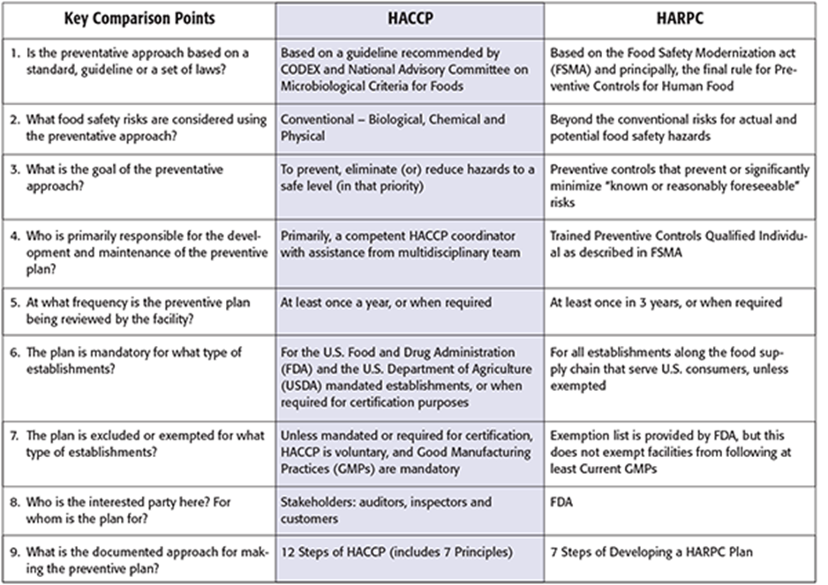
Source: www.fsm.com

CODEX HACCP Basics-12 steps of implementation
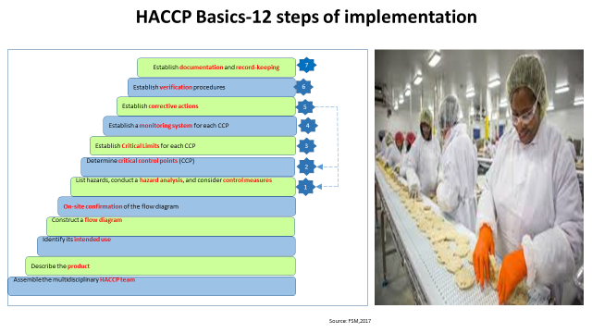

The 12 steps of CODEX HACCP implementation incorporates the 7 Principles namely:
- Principle 1 - Conduct a Hazard Analysis.
- Principle 2 - Identify the Critical Control Points
- Principle 3 - Establish Critical Limits.
- Principle 4-Establish Monitoring of CCP procedures
- Principle 5 - Establish Corrective Action.
- Principle 6 - Establish verification procedures.
- Principle 7 – Establish Recordkeeping and Documentation procedures.

HACCP is a globally recognized risk-based preventative approach recommended by the Codex Alimentarius Commission (CAC) .It commonly focuses on controlling the three main food safety hazards: biological, chemical and physical. The primary goals (in order of priority) are to prevent occurrences of the hazard, or eliminate, or reduce the food safety hazard to acceptable or safe levels.
The principles of Hazard Analysis and Critical Control Point (HACCP) is now a legal requirement in every industrial operation involving the manufacture, preparation, treatment, processing, transport and storage of food in the European Union (EU). Certain countries such as USA, Canada, and New Zealand legally mandate some HACCP programmes. For example,in the USA, the HACCP program is legally mandated for meat and poultry establishments (under USDA jurisdiction) and juice and seafood processing establishments (under FDA’s jurisdiction) in conjunction with NACMCF.
- steps of Preventive Control for Human Food

Conduct Hazard Analysis
Identify hazards due to the specific foods or food ingredients in the food or due to the various processing, manufacturing, packing, and holding steps applied to the foods. Also facility-specific concerns such as food defense and emergency management issues should be considered.. Once identified, each hazard is evaluated to assess its likelihood of occurring and severity of the illness or injury it would bring (impact). This step is designed to prepare identification of the steps necessary to minimize or prevent the hazards from arising.
To identify the hazards, consider the following known or reasonably foreseeable hazards:
biological hazards,
chemical hazards (including radiological hazards),
physical hazards
Natural toxins, pesticides, drug residues, decomposition, parasites, allergens, and unapproved food and color additives
Naturally occurring hazards or unintentionally introduced hazards
Intentionally introduced hazards for economic gain

After identifying the hazards, each hazard must be evaluated by considering formulation, ingredients, facilities, equipment, production flow, storage, and transportation. Focus should also be on relevant factors that could contribute to each hazard throughout the food facility, its operations and personnel, including personnel screening and controls, the entire supply chain of a facility’s food ingredients (raw materials, packaging, dyes, labels, etc.), and the finished foods received, delivered and shipped.
A written analysis of the above hazards must be maintained for statutory inspection or upon request.
Risk-based Preventive Controls
Develop and implement a series of risk-based controls to significantly minimize or prevent the identified hazards to ensure the safety of the food.
Controls must be designated at food processing steps and manufacturing environment that are appropriate for ensuring the safety of the food, especially, the critical control point (CCP)from the HACCP framework. CCPs are critical manufacturing points, where controls are applied to minimize or eliminate the hazard or reduce the hazard to an acceptable level under normal manufacturing operations.
Examples of types of preventive controls include:
Sanitation procedures at food surface contact points eg CIP
Sanitation of utensils and equipment eg dismantle- and -clean procedures
Staff hygiene training
Food allergen control program
Recall plan
Current Good Manufacturing Practices (cGMPs)
Supply-chain controls
The preventive controls must be written. If a particular hazard will be controlled by another facility in the supply-chain (whether a supplier or later distributor/processor), there must be written assurance from the other facility how the hazard is being controlled.

Establish parameters and values
Critical limits may not be required for some preventive controls. Instead parameters and values are used to assess compliance. The broader term, parameters and values, supports identification of a frequency or other metric to assess compliance, rather than setting a precise minimum or maximum value to which a parameter must be controlled.
Establish monitoring of Effectiveness
A written monitoring program is required which ensures regular evaluations of a facility’s control measures to determine that the preventive controls are working. Statutory inspection by FDA will evaluate the monitoring system to identify inadequacies in either the methods of monitoring or the retained records.
Establish Corrective Actions
Establish and implement written corrective action procedures that will go into effect if:
preventive controls are not property implemented;
there is a question regarding preventive control or food safety plan’s effectiveness;
the records are incomplete, or other discrepancies in implementing the food safety plan.
Immediate corrections (like re‐cleaning a line before start up) may be more appropriate than formal corrective action involving product risk evaluations for some preventive controls.
The corrective action procedures must include the following steps:
Identification of weak spots in the controls
Identification of ineffective controls
Identification of new hazards
Performing necessary steps to reduce the likelihood of recurrence
Evaluating the processed food for safety
Prevention of adulterated food from entering commerce
Establish Verification measures
The process of verification ensures that the facility is effectively meeting its food safety standards on a consistent basis. Some verification activities may be less rigorous for some PC than others
Food facilities shall design and implement verification steps to ensure that preventive controls Plan (including the hazard identification and analysis, preventive controls and control measures, monitoring and corrective action steps) are operating correctly to prevent or minimize food safety and adulteration hazards. Verification steps should be sufficiently robust to ensure that:
The selected preventive controls are adequate
Monitoring is occurring properly as defined in the plan
Appropriate corrective actions are taken
Potential food and food processing hazards are reduced
Periodic reviews are conducted at appropriate intervals so the plan remains working and takes into account new and emerging risks and hazards
Recordkeeping and Documentation
The supply-chain provisions under FSMA require that records and documents related to food hazards and process control systems be established and maintained for no less than 2 years to cover the following:
The monitoring of the preventive controls
The corrective actions
Testing results and other verification steps designed to ensure the preventive controls are effectively minimizing or preventing hazards
Trainings
Supply-chain program
Preventive controls gives flexibility to receiving facilities’ controls on raw materials. If supplier or a third party entity implements controls to manage the hazards associated with raw material or other ingredients, the receiving facility does not need to establish its own preventive controls itself, but can rely on that of the third party or supplier through a risk-based supply-chain program.
Every receiving facility needs to set up a risk-based supply-chain program to make sure that the relevant hazards are appropriately controlled by its suppliers or third party entities. Under the supply-chain program, the receiving facility must first approve suppliers by considering the nature of the hazards and supplier performance. Then, the receiving facility must determine appropriate verification activities to ensure the supplier’s controls significantly minimize or prevent hazards.
Appropriate verification activities may include onsite audits and testing. If the supplier is not controlling the hazards, the receiving facility can also choose to review and the verification conducted by another entity to assess the sufficiency of the controls.
In summary, the contents of the supply-chain program must include:
• Identification and use approved suppliers
• Determining and conducting supplier’s verification activities
• Conducting other facility (non-supplier)’s controls of hazards, or reviewing another entity’s verification activities on the hazards.
The supply-chain program must be written. The receiving facility needs to develop written receiving procedures and document the supplier’s verification activities.

Requirement to Re-analyze
After developing and implementing an adequate preventive Controls plan, the food facility must periodically evaluate its food safety preventive controls (PC) system. The facility must reanalyze its plan:
Whenever there is a significant change at the facility that might increase a known hazard or introduce a new one
Every 3 years (if no other significant changes occur)

Additionally, prevent controls plan requires the facility to perform a new hazard analysis and implement any new, necessary preventive controls before operational changes occur.
Any changes must be documented in the firm’s preventive controls records. If no changes are necessary after a reanalysis of a PC system, the firm must document the basis for that decision.

Vocabulary associated with food safety
For the convenience of the users of this manual and in order to have a common understanding of the terminology used in Food safety, the Appendix1 on Terminology will apply.

EXERCSE 1
Individual activity to march up glossary terms to ensure clear understanding of vocabulary associated with foods safety.
(This will also confirm that Pre- course reading was done)

  - CHAPTER 2: Food Safety Plan Overview
Learning Objectives
To help trainees understand and explain:
- The benefits of using a Food Safety Plan
- The principles applied to build a Food Safety Plan
- A roadmap for building a Food Safety Plan

What is a food safety plan?
A set of written documents that is based on the food safety principles; incorporates hazard analysis, preventive controls, supply-chain programs and recall plan; and delineate ( describes) the procedures to be followed for monitoring, corrective actions and verification
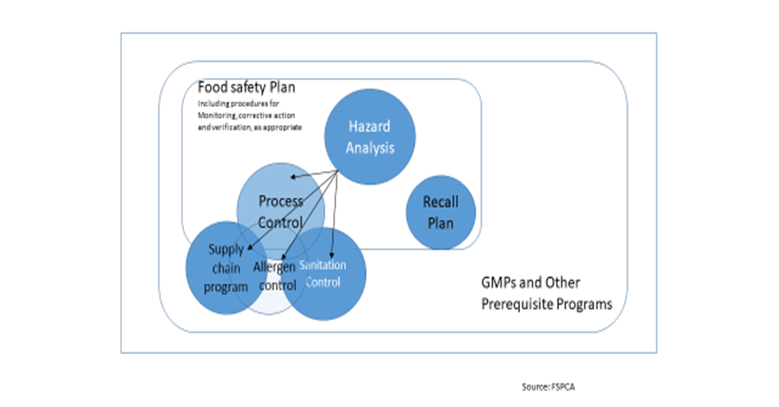
The Food Safety Plan is a dynamic document, which must be kept current if changes are made to the system or to equipment when new products are added, or new hazards are identified

Mandatory elements | Why
- Hazard analysis | Identifies and documents hazards requiring a preventive control
- Preventive controls  - Process, food allergen, sanitation, supply-chain and others  - Recall plan | Needed to control the hazards identified in the hazard analysis.  Must be documented
- Procedures for monitoring, corrective action and verification | To ensure the effectiveness of the controls.  Must be documented
Contents of a Food Safety Plan:

Note 1: GMPs are required because they form the foundation for the Food Safety Plan. Developing a Food Safety Plan helps to focus most activities on what matters most for food safety
Note 2: Elements of GMPs that are not covered in the Food Safety Plan may still be required by food safety regulations depending on the food category
Useful information which makes the Food Safety Plan more comprehensive but not mandatory:
- Facility overview
- Food Safety Team description
- Product description
- Flow diagrams
- Process description
What are the benefits of having a food safety plan?
- Avoid outbreaks
- Avoid product recalls
- Increased confidence
- Compliance

.

Example of outbreak and recall
The 2017–18 South African listeriosis outbreak is an ongoing widespread outbreak of Listeria monocytogenes food poisoning that resulted from contaminated processed meats produced by Enterprise Foods, a subsidiary of Tiger Brands, in Polokwane, South Africa.
- Number of deaths: 200
- Location: South Africa
- Date: 2017 – March 2018
- Non-fatal injuries: 1000 confirmed cases
Source:
National Institute for Communicable Diseases (NICD) from all provinces. Mar 28, 2018
WHO | Listeriosis – South Africa - World Health Organization

Note 1: The link above can be followed to get more details of the outbreak and recall
Note 2 : When two or more people get the same illness from the same contaminated food or drink, the event is called a foodborne outbreak. Public health officials investigate outbreaks to control them, so more people do not get sick in the outbreak, and to learn how to prevent similar outbreaks from happening in the future.

Principles applied to build a food safety plan
Developing a Food Safety Plan:
- hazard analysis and identification of hazard that matter most for food safety
- determining preventive controls that are essential to prevent the hazard from causing illness or injury are identified
- determine relevant parameters that define the conditions that must be met to effectively manage the hazard.
- Monitoring –planned sequence of activities to assess control measures are operating
- Corrective actions or corrections are predefined to enable swift action when things go wrong,
- Some elements of a preventive controls system also require validation to demonstrate that the controls actually work. This activity may be less rigorous for some preventive controls than others.
Scope of the of the food safety plan
Consider:
- The specific product(s) and process(es) that the Food Safety Plan will address,
- The part of the food chain to be considered (e.g., products sold to retail may have different considerations than those sold to foodservice, to manufacturers or directly to the consumer), and
- Hazards associated with the above

The scope of the Food Safety Plan may be influenced by regulatory requirements or specific requirements instituted by a customer.

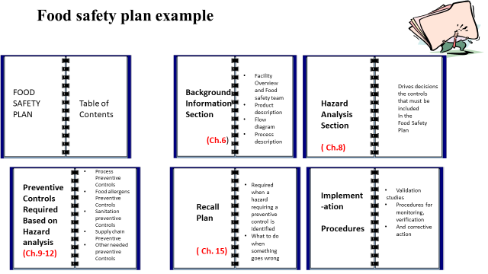
Note 1: the red text highlights the chapter of the manual where the section of the plan is elaborated
The Food Safety Plan
Is a written document that is specific to the facility.
- It must contain a hazard analysis
- It must contain separate plans or programs that address process preventive controls.
- It must also contain a recall plan for food where a hazard requiring a preventive control has been identified
- Implementation procedures.
NB:There is no required format for these documents or for the Food Safety Plan itself. Some facilities may combine different sections; some may separate them.

There is no requirement that all parts of the Food Safety Plan be located in one place.
Records to demonstrate preventive controls management MUST be maintained
All documents must be easily retrievable e

Chapter 3 Good Manufacturing Practices and other Prerequisite programmes
Learning Objectives:
To help trainees understand and explain:
- Prerequisite programmes and their importance in Food safety System
- Basic requirements of Good Manufacturing Practices ( GMP) for human food
- Distinguish between GMP and cGMP

What are Good Manufacturing Practices (GMP) and cGMPs?
The conditions and practices the food industry must follow for processing safe food under sanitary conditions, including personnel, plant and premises, sanitary operations, sanitary facilities and controls, equipment and utensils, processes and controls ,warehousing and distribution ,and defect action levels considerations.
In the context of FSMA,GMP refers to the Good Manufacturing Practice Regulations which have the force of law, that require manufacturers, processors, and packagers take proactive steps to ensure that their products are safe. GMP regulations require a quality approach to manufacturing, enabling companies to minimize or eliminate instances of contamination, mix-ups, and errors.

"cGMP": The letter "c" stands for "current," prompting manufacturers that they must employ technologies and systems that are up-to-date in order to comply with the regulation.

What are pre-requisite programmes?
Procedures, including Good Manufacturing Practices (GMPs), that provide the basic environmental and operating conditions necessary to support the Food Safety Plan.
The foundational programs that are part of the food safety system are frequently termed prerequisite programs. The term was coined to indicate that they should be in place before Risk-based systems are implemented in order to effectively manage risk from foodborne hazards.
Most national and regional food safety regulations prescribe Good Manufacturing Practice (GMP) which address requirements for many prerequisite programs. Not all GMPs are applicable to all food processing facilities. There are programs that are likely to apply to most facilities, such as supplier and manufacturing specifications.
Prerequisite programs ( PRPs) provide the basic environmental and operating conditions that are necessary to support a Food Safety Plan and in some cases these programs will be part of the Food Safety Plan. The specific prerequisite programs required may vary depending on the type of food produced and the facility where it is processed or held.

The terms prerequisite program, GMP, cGMP "good hygienic practice" ( GHP)and "sanitation standard operating procedures" ( SSOP) are used interchangeably with GMP. They are included in an overall food safety system. Without these programs, the Food Safety Plan may not successfully prevent food safety issues.
GMPs also provide for defect action levels for natural or unavoidable defects that at low levels are not hazardous to health. There may be some instances where a specific GMP task is so important to the safety of the product that it is designated as a preventive control in a Food Safety Plan. This is determined during hazard analysis and most likely would occur if there are cross-contamination (in a ready-to-eat food) or allergen cross-contact issues that need to be addressed in written sanitation or allergen preventive controls.

The GMP regulations do not require written procedures, monitoring or record-keeping (except for training records); however, they are recommended as part of a facility's Standard Operating Procedures (SOPs) to manage the GMPs and document the results of these important programs.

EXERCISE 2
Group work on GMPS and cGMPS and other pre-requisite programmes.
Discussion of each element followed by presentations and plenary discussions

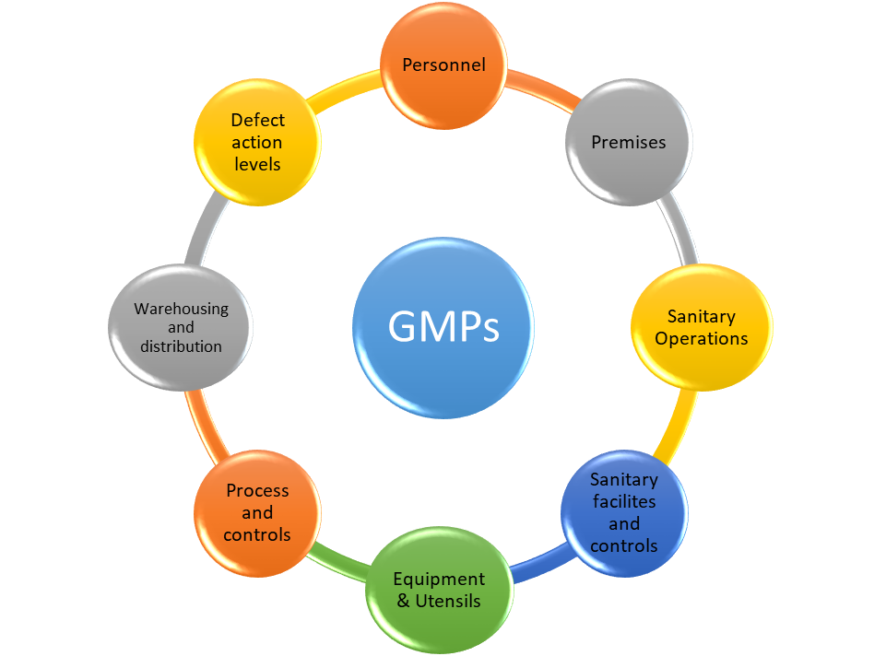
Also to be discussed with appropriate examples:
Other PRPs such as
- Hygienic zoning
- Supplier and product specification
- Preventive maintenance
- Signage or color coded equipment
- Others…….

Chapter 4 Food Safety Hazards- Biological food hazards
Learning Objectives:
To help trainees understand and explain:
- The definition of the term “ Hazard”
- The different categories of food hazards
- Importance of understanding hazards associated with food products and processes
- Potential controls for each category of hazard

What is a food safety hazard?
Any biological, chemical (including radiological), or physical agent that has the potential to cause illness or injury

The 12 detailed Categories of Hazards under Preventive Controls
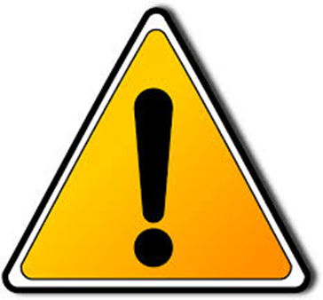
1. Biological 2. Chemical 3. Physical
4 .Radiological 5. Natural Toxins 6. Pesticides
7. Drug Residues 8. Decomposition
9. Parasites 10. Allergens 11. Unapproved Additives
12. Intentional-EMA

What is not considered a food safety Hazard?

Biological food safety hazards
Biological hazards include pathogenic bacteria, viruses and parasites.
These normally cause food borne illness which can be classified as Foodborne infections or food borne intoxication.
Where two or more people get sickened form the same source of food this is referred to as an outbreak
Biological agents have been noted to cause more outbreaks than other agents
A lot of cases are unreported hence” tip of the Iceberg” effect.
There are several data collecting bodies such as Centre for Disease Control(CDC . USA), WHO, NICD( RSA)and other such bodies
In the USA there is a legislated Reportable Food Registry.
What is a reportable food registry?
This registry collects information through an electronic portal from the food industry and from public health authorities on foods or feed that are likely to cause serious adverse health consequences or death to humans or animals if they are used. Biological hazards represent the primary category of hazards reported through the registry. However, undeclared allergens in food represent about one third of the reports

There has been reportable cases of Macadamia nuts imported from several African countries containing Salmonella spp (FDA Food program 1st annual Report 2010)

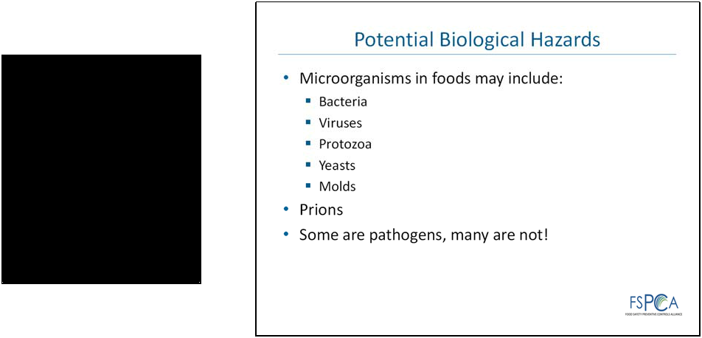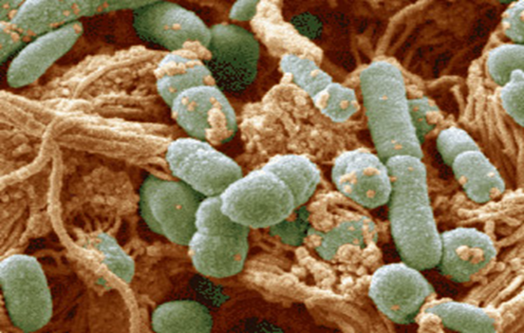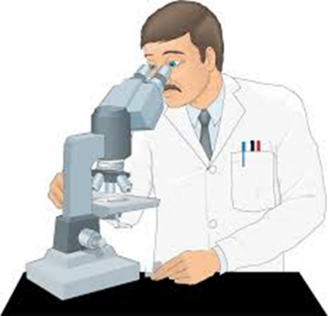
What are pathogens and what is their relationship with Foodborne infections and Food borne intoxications?
Pathogens are microorganism that can cause disease.
When they enter the body through consumption of unsafe food they can cause foodborne infections or foodborne intoxications

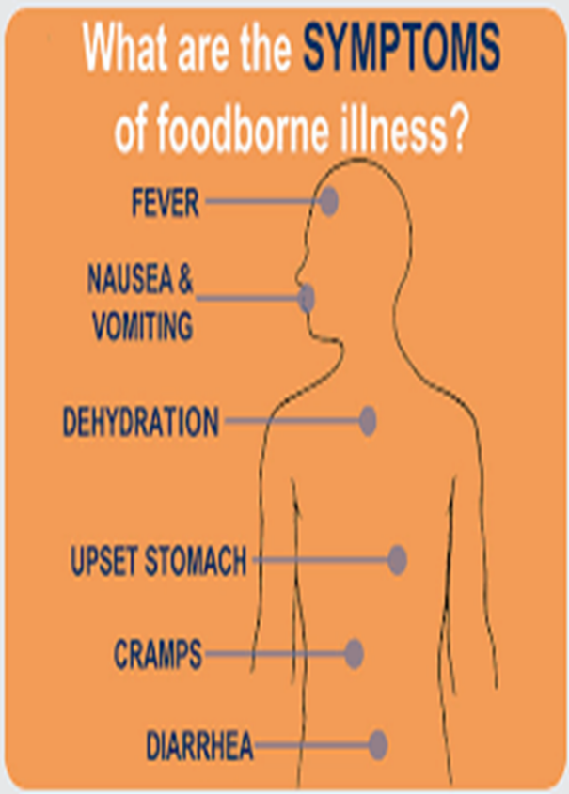
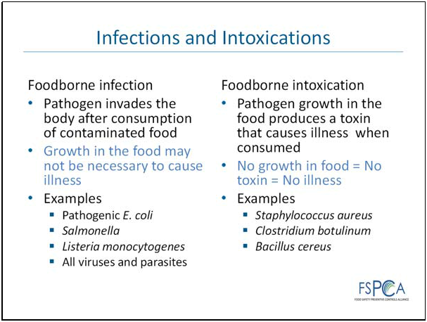
Foodborne illness can result in self- limiting illness, illness requiring hospitalization, cause death particularly in vulnerable populations: Children under 5 years, elderly persons, immuno-compromised people.

What are the sources of biological hazards?
Sources are the likely situations that would promote or cause biological hazards to contaminate food

Sources of biological hazards and potential controls

1. People:

2. Ingredients:

3. Environment

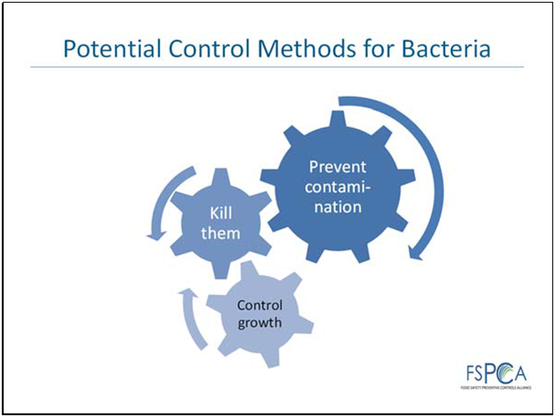

Three basic strategies can be used to control bacterial pathogens\
in food –
- prevent contamination
- kill them and
- control growth.

EXERCISE 3
Methods of controlling bacteria
Group work for the strategies used to prevent, kill and control growth of Bacteria in food with appropriate examples.
Control combinations are also feasible
    - Killing or destruction of bacteria ( Spores vs, Vegetative cells)
    - Controll/Prevent growth ( Factors influencing growth eg pH, Atmosphere, Competition, water activity)
    - Prevention of contamination.

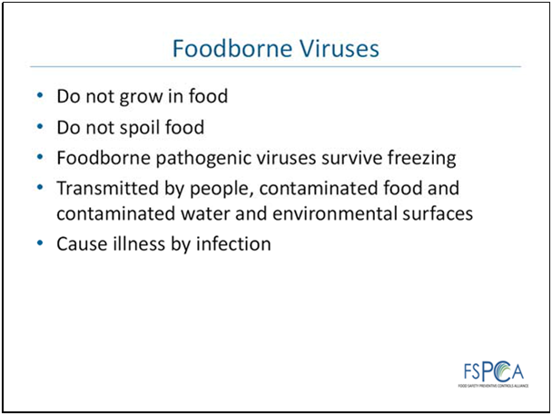

Viruses are normally host –specific. Viruses cause illness by infecting living cells and reproducing inside the host. Viruses grow only in a suitable host and only certain viruses infect humans. Infected people are the primary source of foodborne viruses. Foodborne viruses of concern can survive in human intestines, contaminated water, frozen foods and environmental surfaces for weeks or months
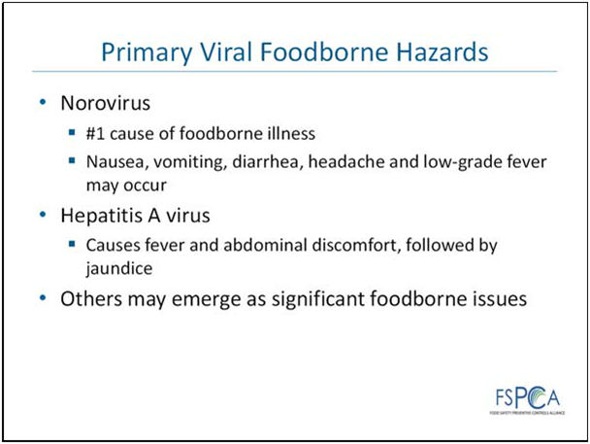

According to WHO the most common foodborne viral hazards are norovirus which also the leading cause of foodborne illness in the world.) Hepatitis A virus( HAV) also continues to pose an international health threat Other viruses, such as rotavirus, may occasionally be associated with foodborne illness such Hepatitis E, and more may be identified in the future. While the vast majority of viral outbreaks occur in foodservice settings, outbreaks have been associated with processed foods. For example, a large norovirus outbreak occurred in Germany that was associated with frozen strawberries imported from China.
There is also seems to a scientifically proved link between bushmeat and Ebola Virus in certain parts of West Africa.

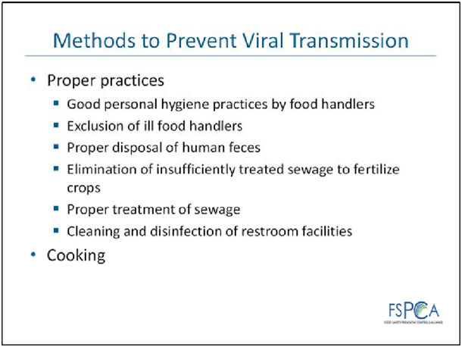
Disinfection;Norovirus is resistant to normal sanitizers and requires special disinfectants approved by Environment protection Agency ( EPA) of US or ECHA ( European Chemical Agency) in the EU
Transmission of viruses to foods is usually related to poor employee hygienic practices such as improper hand washing or working while actively shedding viruses .Viruses can infect consumers through contact with infected people or contaminated food or water. People who are ill from a viral illness can shed viruses in very high numbers in vomit or feces. Even when they recover from the illness and no longer show outward signs of illness, people can still shed the virus in saliva and feces..
Exclusion of ill food handlers: Therefore, prohibiting people with viral illnesses from coming into direct contact with food reduces the chance for foodborne transmission of viruses. Person‐to‐person transmission is very common for the viruses associated with foodborne illness outbreaks, which is another reason for requiring ill individuals to stay home from work – it prevents other workers from contracting the disease and spreading it to food. Outbreaks have been traced to foods exposed to inappropriately treated water. This may be rare in developed countries, but may be a concern in certain regions of the world.
Thorough cooking is also an effective control mechanism and most foods associated with viral foodborne outbreaks are ready to eat. There is some evidence that high pressure processing may also be effective in reducing the risk of transmitting foodborne viruses, and exploration of validated processes for specific foods is necessary for this control strategy.

Food borne Parasites
The top ten are:
- Taenia solium (pork tapeworm): In pork
- Echinococcus granulosus (hydatid worm or dog tapeworm): In fresh produce
- Echinococcus multilocularis (a type of tapeworm): In fresh produce
- Toxoplasma gondii (protozoa): In meat from small ruminants, pork, beef, game meat (red meat and organs)
- Cryptosporidium spp.(protozoa): In fresh produce, fruit juice, milk
- Entamoeba histolytica (protozoa): In fresh produce
- Trichinella spiralis (pork worm): In pork
- Opisthorchiidae (family of flatworms): In freshwater fish
- Ascaris spp. (small intestinal roundworms): In fresh produce
- Trypanosoma cruzi (protozoa): In fruit juices
Source:FAO's food safety and quality unit ,2019
Like viruses, foodborne parasites do not grow in food. There’s a strong correlation with parasitic foodborne and water associated diseases and poor sanitation.

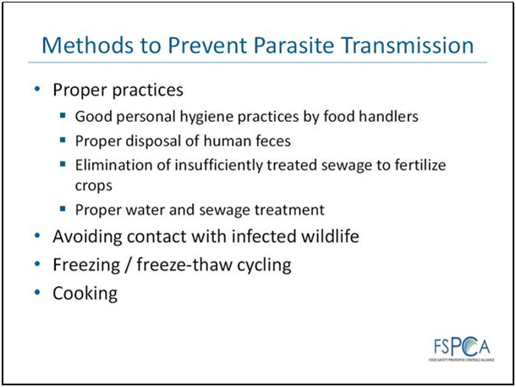

Which Foods are associated with foodborne pathogens?
Certain foods are most commonly associated with certain pathogens than others.
As a general rule, any food which can support viability and growth of foodborne pathogens is capable of causing foodborne illness when consumed.

Consideration of the different pathogens allows the design of a food safety system that will control all of the different pathogens. This is usually done by designing the control procedure to be effective against the pathogen that is most resistant to the procedure. For example, if heat treatment is used to destroy pathogens, setting the time/ temperature combination to kill the most resistant pathogen would ensure all other pathogens are destroyed .
- Campylobacter
- Salmonella
- Brucella
- Mycobacterium Species
- Strep Group A
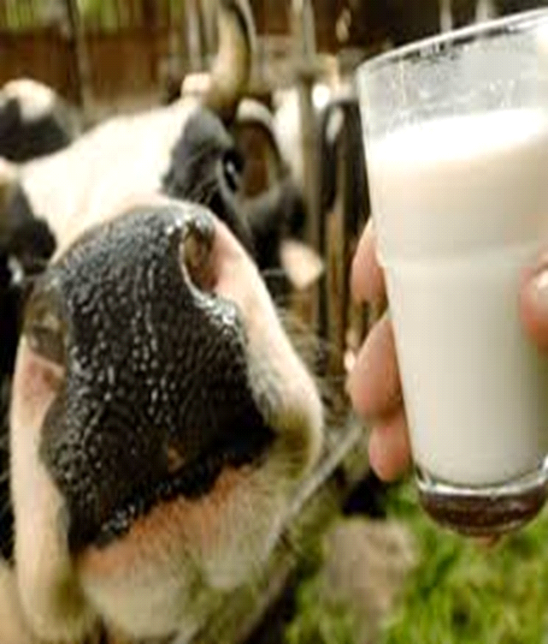
Raw milk and raw milk products
Another reason for considering individual pathogens is that if a new pathogen is identified as a concern (and this happens from time to time), it can be easily checked whether the food safety plan had considered it or not.

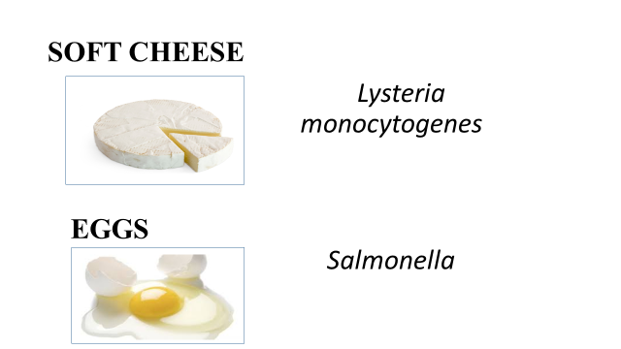

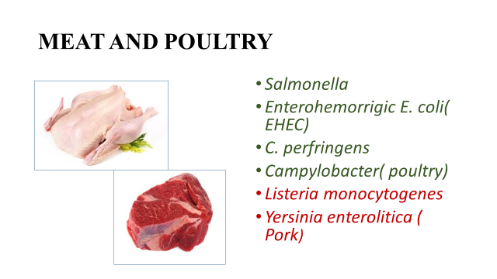
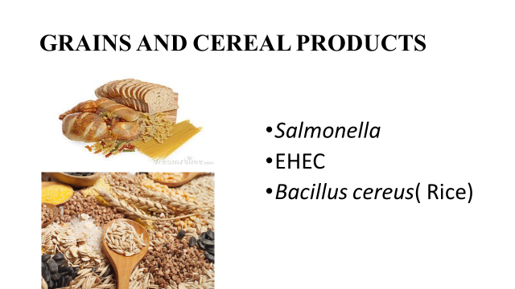

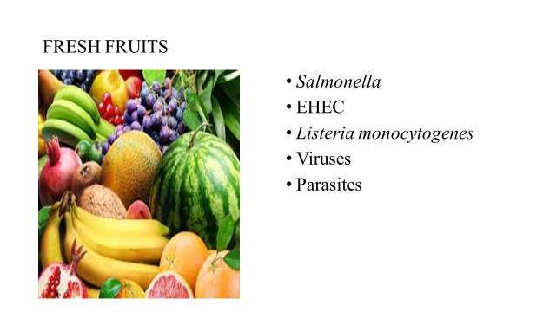

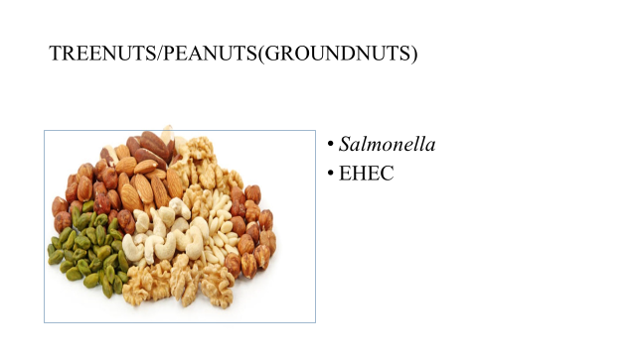

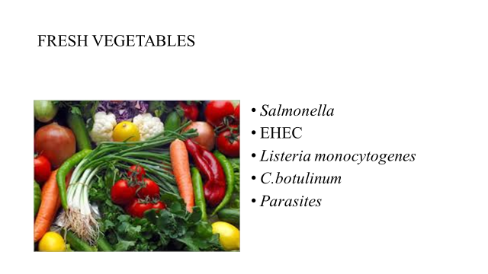

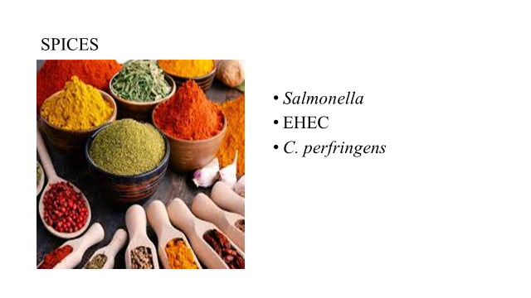

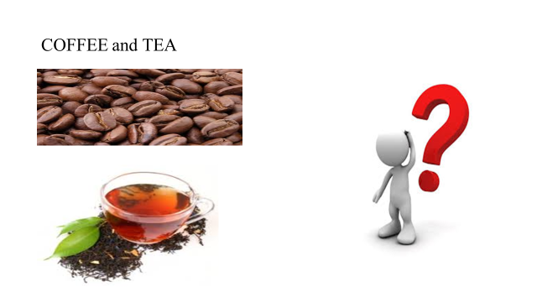
Note1: The above pathogens should be considered when carrying out hazard analysis for the specific food category.
Note 2: The list for each category of food is not exhaustive

CHAPTER

Chemical, Physical and Economically Motivated Food Safety Hazards
Learning Objectives:
To help trainees understand and explain:
- The definition of the term “Chemical, Physical and Economically Motivated Food Safety Hazards”
- The different categories of Chemical, Physical and Economically Motivated Food Safety Hazards”
- Potential controls for each category of hazard
What are chemical hazards?
Chemical hazards include substances that can cause illness or injury due to immediate or long-term exposure.
Examples are:
Natural Toxins , Radiological hazards, Pesticides , Veterinary Drug Residue , Allergens, Heavy metals,Decomposition products, Unapproved Additives

- Natural Toxins eg cyanogenic glycosides in raw or unprocessed cassava ; poisonous neurotoxins in mushrooms; aflatoxins in peanuts and other mycotoxins.
- Radiological Hazards eg food may become contaminated through the absorption of radioactive chemicals found in soil, air or water. Radioactive chemicals are of concern after nuclear power plant accidents eg in the 1986 Chernobyl nuclear power plant accident or in the 2011 Fukushima nuclear power plant accident in Japan.
- Pesticides eg used control pests such as insects, rodents, weeds, bacteria, mold and fungus.There stringent safety standards for pesticide residues and their metabolites in food as well as acceptable pesticides to be used in food through pesticide registration.
- Veterinary Drug Residues eg veterinary drug residues and metabolites retained in animal food products
- Allergens eg
- Heavy metals eg
- Decomposition products eg
- Unapproved additives eg

What are Physical Hazards?
Any extraneous object or foreign matter in a food item which may cause illness or injury to a person consuming the product. These foreign objects include, but are not limited to bone or bone chips, metal flakes or fragments, pieces of product packaging, stones, glass or wood fragments, insects or other filth, personal items, or any other foreign material not normally found in food products.
9
Main Materials of Concern as Physical Hazards and Common Sources
Material | Injury Potential | Sources
Glass | Cuts, bleeding; may require surgery to find or remove | Bottles, jars, light fixtures, utensils, gauge covers
Wood | Cuts, infection, choking; may require surgery to remove | Fields, pallets, boxes, buildings
Stones chippings/paint | Choking, broken teeth | Fields, buildings
Jewelry and personal effects | Cuts, infection; may require surgery to remove | Pens/pencils, buttons, careless employee practices.
Metal | Cuts, infection; may require surgery to remove | Machinery, fields, wire, employees
Insulation | Choking; long-term if asbestos | Building materials
Bone | Choking, trauma | Fields, improper plant processing
Plastic | Choking, cuts, infection; may require surgery to remove | Fields, plant packaging materials, pallets, employees
Source: https://food.unl.edu/physical-hazards
What are economically Motivated chemical hazards ( economically motivated Adulteration-EMA)?
Fraudulent, intentional substitution or addition of a substance in a product for the purpose of increasing the apparent value of the product or reducing the cost of its production, i.e., for economic gain.
Some examples of relevant Food Categories with reported cases of Food EMA
- Honey: Honey might have added sugar syrup, corn syrup, fructose, glucose, high-fructose corn syrup, and beet sugar, without being disclosed on the label. Honey from a “nonauthentic geographic origin” is also common, such as cases where honey from China is transshipped through another Asian country and falsely sold as honey from the second country—usually to avoid higher customs duties and tariffs that would be imposed on honey from China. Some of this honey might also contain unapproved antibiotics or other additives and heavy metals.
- Fruit Juice. Juices might be watered down, or a more expensive juice (such as from pomegranates or other “super” fruit) might be cut with a cheaper juice (such as apple or grape juice). Some juice may be only water, dye, and sugary flavorings, although fruit is the listed ingredient on the label. Orange juice has been shown to sometimes contain added unlisted lemon juice, mandarin juice, grapefruit juice, high fructose corn syrup, paprika extract, and beet sugar.
- Coffee and Tea. Ground coffee might be cut with leaves and twigs, as well as roasted corn, ground roasted barley, and roasted ground parchment. Instant coffee may include chicory, cereals, caramel, more parchment, starch, malt, and figs. Tea may contain leaves from other plants, color additives, and colored saw dust.
- Spices. Saffron is the world’s most expensive spice, and has been found to have added glycerin, sandalwood dust, tartrazine (a yellow dye), barium sulfate, and borax. Ground black pepper has been shown to have added starch, papaya seeds, buckwheat, flour, twigs, and millet. Vanilla extract, turmeric, star anise, paprika, and chili powder are other spices prone to fraud. Sudan red dyes have been used to color paprika, chili powders, and curries, but are also known carcinogens and are banned for use in foods.
- Organic Foods and Products. Using fraudulent certification to market, label, or sell non-organic (conventionally produced) agricultural products
Source: https://fas.org/sgp/crs/misc/R43358.pdf CRS compilation from information reported by USP, Michigan State University, NCFPD and researchers at the University of Minnesota, Oceana, Consumers Union, Food Chemical News, and the Rodale Institute.

Potential controls of Chemical, physical hazards and EMA

- Supply chain controls:

Every food manufacturer must create a written Food Safety Plan and operate based on that plan. A Preventive Controls Qualified Individual must author the plan. A person can become a PCQI by completing this training course offered by the Food Safety Preventive Controls Alliance, or through work experience.
The Food Safety Plan can include preventive controls administered along the supply chain, especially when an ingredient has a history as a hazard. The PCQI makes this determination when he or she does a hazard analysis, which identifies where the possibility of unsafe food occurs within the production process. Some ingredients, such as vinegar, do not have a safety hazard; others, such as spices, can come into your facility with serious food safety issues. You do not need a supply chain program if the preventive control for that hazard is applied within your facility.
Often, the hazard can be controlled before the ingredient enters your manufacturing facility. Companies from which you purchase ingredients are most likely to apply supply chain preventive controls, but, in some instances, companies to which you sell your product can apply them. The control of a hazard—and your responsibility to make sure the control had been applied—is the basis of your Supply Chain Program.
The FSMA regulation defines the supply chain as consisting of Supplier, Receiving Facility, and Customer. The manufacturer/processor is the Receiving Facility. Your Supplier can be a manufacturer/processor, importer, farm, or ranch that provides the raw ingredients. Your Customer can be another manufacturer/processor or a foodservice or retail establishment.
A Supply Chain Program is not required when:
- No hazards exist.
- Receiving Facility controls the hazard.
- Customer or others down the supply chain control the hazard.
Requirements of Your Supply Chain Program
The regulations state five general requirements for controlling your supply chain:
- Use approved Suppliers.
- Determine Supplier verification activities.
- Conduct Supplier verification activities.
- Document Supplier verification activities.
- If necessary, verify a supply chain control applied by an entity other than your Supplier.
The requirements are simple, in theory, but will require time and diligence to implement.
The first and most important step is to use approved Suppliers. It is your responsibility to approve the Suppliers before you receive the raw ingredient, which can be challenging when you have a multitude of Suppliers and/or switch Suppliers based on ingredient availability and price. FSMA requires written procedures for receiving the ingredients from approved Suppliers, as well as records documenting that the product is safe when it is received.
You must conduct verification activities before accepting an ingredient or food from a Supplier. These verification activities can include an on-site audit, sampling and testing by the Supplier or Receiving Facility, and/or a review of the Supplier’s food safety records for the ingredient. Once the Supplier has been verified, you can perform these activities less frequently, depending on the safety risk of the raw material. The regulation stipulates various considerations for verification, including the Supplier’s procedures, processes, and practices for the safety of the ingredient; past FDA warning letters to the Supplier; the Supplier’s corrective actions; and whether the Supplier has good storage and transportation practices. You also need to consider country of origin.
It is your responsibility as the Receiving Facility to approve the Supplier. Although the Supplier can send you information regarding the safety of its food or ingredients, you must document that the information is accurate and meets your requirements. If a serious health hazard could exist, you are required to initiate an on-site audit using a qualified auditor, who can be a government employee or the agent of an accredited certification body. These audits must occur at least annually and should include both records review and an in-person observation of practices. If you have a PCQI on staff, you can use that person to do the audit.
When a gap in supplier performance is identified, you must make sure that the food you have manufactured with that ingredient is not adulterated or contains unidentified allergens. If the food is unsafe, you must have a plan for corrective action and recall.
The specialty food industry thrives on innovation. Specialty food manufacturers often change the foods and ingredients used to create their products. The Supply Chain Program needs to reflect this constant change.
Two types of change need to be considered: changes made by the Supplier and/or changes made by the Receiving Facility. When a Supplier makes a change, they must immediately report it to the Receiving Facility so that they can document the change and whether it will impact the Food Safety Plan.
More likely, the specialty food manufacturer will choose a new Supplier based on quality, price, availability, or other business factors. These changes must be communicated to the internal Food Safety Team so they can determine whether the new Supplier or ingredient should be controlling a hazard, and then set up a Supply Chain Program to make sure the Supplier complies.
FSMA requires documentation of your Supply Chain Program. This must include:
- written Supply Chain Program;
- for import facilities, Foreign Supplier Verification Program compliance documents;
- documentation of Supplier approval;
- receiving procedures;
- receiving records;
- determination of appropriate Supplier verification activities.
Importers and the supply chain program
Management of the supply chain for importers is similar to that required by domestic manufacturers. The Foreign Supplier Verification Program requires importers to monitor the Food Safety Plans of their foreign suppliers. These Food Safety Plans should have a Supply Chain Program if a hazard is controlled before the food or ingredient arrives at the facility that processess the final product before it is exported.
In some circumstances, the importer would implement the preventive control before selling the product to a domestic manufacturer, i.e., Receiving Facility. In that case, the Receiving Facility would treat the importer as part of its Supply Chain Program. An importer will also be in compliance if the preventive control is implemented by the manufacturer purchasing the product, and it verifies that the control is part of its customer’s Food Safety Plan.
For instance, importers of coffee beans and cocoa beans often purchase from many farms. These products cannot be consumed without further processing that controls hazards. Importers are not required to verify the safety of the supply chain for these products. They do need to make sure that the entities to which they sell the food are controlling the hazard.
As the specialty food industry becomes more aware of FSMA and its implications, management of the supply chain is an important aspect of any company’s Food Safety Plan.

- Sanitation controls
As appropriate to the facility, food, procedures, practices and processes, these sanitation controls must include: (1) cleanliness of food-contact surfaces, including utensils and equipment; and (2) prevention of allergen cross-contact and cross-contamination from insanitary objects, personnel, and raw product.
So how do you determine which hazards require a sanitation control, and which can be protected through GMPs? Through your hazard analysis. Thus,
First assess the sanitation procedures, practices, and processes that you will have in place to comply with the CGMP requirements.
Cross-Contact & Cross-Contamination. Food-Contact Surfaces. The CGMPs include specific requirements for cleaning food-contact surfaces, however it does not define the term “cleaning.” So FDA has added a definition to the term for the guidance: cleaning mean removing the soil (i.e., bacteriological nutrients, such as fats, carbohydrates, proteins, and minerals) that can build up on food-contact surfaces in the plant and processing equipment. The CGMPs do define sanitize (i.e., adequately treating cleaned surfaces by a process that is effective in destroying vegetative cells of pathogens, and in substantially reducing numbers of other undesirable microorganisms, but without adversely affecting the product or its safety for the consumer.) When systems (such as steam systems) both clean and sanitize surfaces, FDA consider these to satisfy the definition of ‘‘sanitize.’’

In determining the need for, and scope of, a hygienic zoning program, you should take into account the structure of your plant, packaging, personnel and ingredient traffic flows, cross-over areas, and potential contaminants from raw materials, air flow, support areas, and other facility activities. While some facilities implement hygienic zoning for quality reasons (e.g., to control mold contamination) the sanitation controls that are the subject of this guidance need only address food safety

- Allergen controls
Food allergen controls must include procedures, practices, and processes employed to ensure protection of food from allergen cross-contact and to properly label the finished food. This chapter provides some general examples (below), while referencing the forthcoming Chapter 11 for in-depth guidance. Examples given in this chapter are:
- Identifying and marking allergen-containing ingredients at receiving;
- Segregating and storing allergen-containing materials at receiving and warehousing;
- Scheduling production of products based on allergen-containing recipes;
- Physical separation of processes for non-allergen-containing and allergen-containing products;
- Sanitation and cleaning practices;
- Using full wet cleaning to remove allergenic materials prior to producing a non-allergen-containing product on the same line;
- Using dedicated cleaning utensils and equipment for removing allergenic materials from food processing equipment.
- Performing label review for each new batch of labels received at the facility;
- Implementing procedures for application of correct label to product.

- Process preventive controls
Process controls include procedures, practices, and processes to ensure the control of parameters during operations such as heat processing, acidifying, irradiating, and refrigerating foods. Process are specific to the food product and the process. A process controls could be (i) parameters associated with the control of the hazard; or
(ii) The maximum or minimum value, or combination of values, to which any biological, chemical, or physical parameter must be controlled to significantly minimize or prevent a hazard requiring a process control.”
Process preventive controls would be typical CCPs in HACCP. A process preventive control is linked to a particular point in the process or a particular piece of equipment.
It is important to understand which of your preventive controls need to be labelled as process preventive controls, as the FDA would expect you to apply critical limits to these types of controls where possible and that you validate them.
It is even more important to understand which of your preventive controls need to be labelled as process preventive controls or CCPs – when you are trying to meet HACCP requirements as well.
- Recall Plan
Now that you've figured out all the hazards requiring a preventive control that could impact the foods you produce, you must (there's that "must" word again) establish a written recall plan for the food. The written recall plan is to include procedures that describe the steps to be taken, and the person responsible to take the steps, including:
- Direct consignee notification of the food being recalled, including how to return or dispose of the affected food.
- Public notification of any hazard presented by the food when appropriate to protect public health.
- Effectiveness checks to verify that the recall is carried out.
- Appropriate disposal of recalled food (e.g., reprocessing, reworking, diverting to a use that does not present a safety concern, or destroying the food).
- FDA also makes recommendations for preparation steps you can take to reduce the disruption of a recall, including:
Adequately code products to enable positive lot identification and facilitate effective recall of all violative lots.

Maintain product distribution records as are necessary to facilitate location of products and keep them for a period of time that exceeds the shelf life and expected use of the product.

