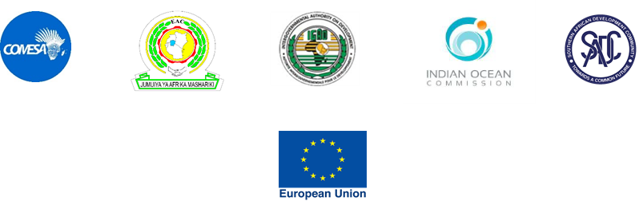

CONSULTANCY SERVICES TO IMPLEMENT HARMONISED REGULATORY/TECHNICAL FRAMEWORKS AND SYNTHESIZED RENEWABLE AND ENERGY EFFICIENCY STRATEGIES IN THE EA-SA-IO REGION
UNDER THE EU PROJECT ON
ENHANCEMENT OF A SUSTAINABLE REGIONAL ENERGY MARKET IN EASTERN AFRICA, SOUTHERN AFRICA, AND INDIAN OCEAN (EA-SA-IO) REGION

ADDENDUM 1: EXTENSION OF SUBMISSION DEADLINE

THIS IS TO NOTIFY ALL INTERESTED BIDDERS THAT THE DEADLINE FOR THE ABOVE TENDER HAS BEEN EXTENDED FROM 30TH SEPTEMBER 2019 AT 15.00 HOURS CENTRAL AFRICAN TIME TO 15TH OCTOBER 2019 AT 15.00 HOURS CENTRAL AFRICAN TIME.

THE REST OF THE CONTENT OF THE REQUEST FOR PROPOSALS REMAINS THE SAME.

MR. JOSEPHAT KINYELE: HEAD OF PROCUREMENT

