

COUR DE JUSTICE

COMESA

مـــــحـكمـة العــــــدل



COURT OF JUSTICE

Distr
RESTRICTED

CS/ADM/SC/XXII/5.2
October 2019

Original: ENGLISH

COMMON MARKET FOR EASTERN AND
SOUTHERN AFRICA

Twenty Second Meeting of the Sub Committee on
Audit and Budgetary Matters

Lusaka, Zambia
28 October – 1 November 2019

BUDGET PERFORMANCE REPORT FOR
COMESA COURT OF JUSTICE AS AT 31st AUGUST 2019

Theme: “Ensuring Economic Integration by Bringing Justice to the Common Market”

(NLM/sk)

- INTRODUCTION

- The Court of Justice of the Common Market for Eastern and Southern Africa (COMESA Court of Justice) was established in 1994 under Article 7 of the COMESA Treaty as one of the Organs of COMESA. The Court is comprised of two Divisions; the Appellate Division and the First Instance Division and composed of twelve Judges, five of whom constitute the Appellate Division and seven constitute the First Instance Division. The day-to-day operations of the Court are coordinated through a Court Registry which is headed by a Registrar.

- The Court sits on ad hoc basis, meaning that it sits as and when it has cases, but holds Administrative Meetings to discuss strategic issues and make decisions on policy issues concerning the Court. Pursuant to Rule 4(1) of the Rules of Court (2016), the Court may hold its court sessions and Administrative Meetings in any Member State on a need-to-basis.

Mandate of the Court

- The Court’s primary function is to uphold the rule of law in the enforcement of the COMESA Treaty by ensuring adherence to the law in the interpretation and application of the Treaty. Its general jurisdiction is to adjudicate as well as to give advisory opinions and arbitrate on any matters that may be referred to it under the Treaty. These matters may be between Member States, Member States and the Council, the Common Market and Member States, between legal and natural persons resident in Member States or between COMESA or its institutions and their employees.

The 2019 Budget

- The 2019 Budget of the COMESA Court of Justice amounting to COM$2,789,793 was approved by the Thirty Ninth Meeting of the Council of Ministers in 2018. The Budget is based on the Court’s five-year 2016 – 2020 Medium Term Strategic Plan (MTSP) and the 2019 Work Programme (WP). The Budget was prepared in accordance with Article 42 of the COMESA Treaty as read together with Chapter II of the COMESA Court of Justice Financial Regulations and covers the period January to December 2019 Financial Year. This Budget Performance Report covers the period 1st January to 31st August 2019. The Thirty Ninth Meeting of the Council of Ministers while considering the 2019 Budget also considered a request from the Court to purchase a motor vehicle at a cost of COM$65,000.

- The Court in 2019 continued implementing both its Medium-Term Strategic Plan – 2016 – 2020 (MTSP 2016-2020) and its 2019 Work Programme. To implement the 2019 Work, Programme the Court focused on the following areas:

- Seeking the required resources to enable it to carry out publicity seminars in Member States, hold regular court sessions and meetings;

- Working with the COMESA Secretariat, to continue with the efforts of mobilising contributions from Member States and extra budgetary resources to finance the Court’s activities;

- Conducting training for the Honourable Judges and members of staff of the Registry on relevant areas such as international judicial systems, court administration, case load management, Alternative Dispute Resolution (ADR), Enterprise Risk Management and new developments in financial and auditing international standards among others;

- Continuous improvement of the Court’s governance rules and institutional development to ensure that the Court plays its role efficiently; and

- Continuous development of the Court’s ICT, exploring and implementating appropriate Management Information Systems to facilitate research, communication, publicity as well as accessibility of the Court’s services and service delivery.

- Status OF MEMBER States’ contributions as at 31st AUGUST 2019

- The Meeting is invited to note Article 166(6) of the COMESA Treaty, which provides as follows on the remittal of contributions by Member States to the Court of Justice Budget:

“Fifty per cent of the contributions for each Member State shall be paid into the budget of the Court of Justice within one month from the beginning of the financial year to which they relate, and the remainder shall be paid within six months from the beginning of the financial year”.

- The Meeting is informed that Member States experiencing difficulties in meeting their financial obligations on time are facilitated by a COMESA Authority decision to clear their arrears over an agreed period while remaining up-to-date with their current assessment.

Analysis of the contributions received during the period under review

The Meeting is invited to note that during the period under review, contributions amounting to COM1,904,938 had been received.

- Table I below analyses the total amounts received of COM$1,904,938 by indicating the amounts received towards arrears and the budgetary contributions received towards the current year contributions.

TABLE I
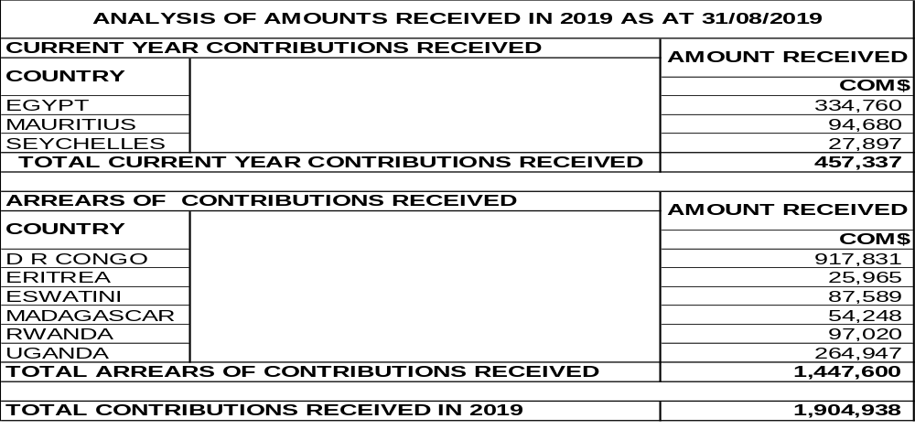
- Table II below, analyses the total contributions received as at 31st August 2019, out of the budgeted sum of COM$2,789,793. It also indicates the arrears and the 2019 assessed contributions so far received.
TABLE II
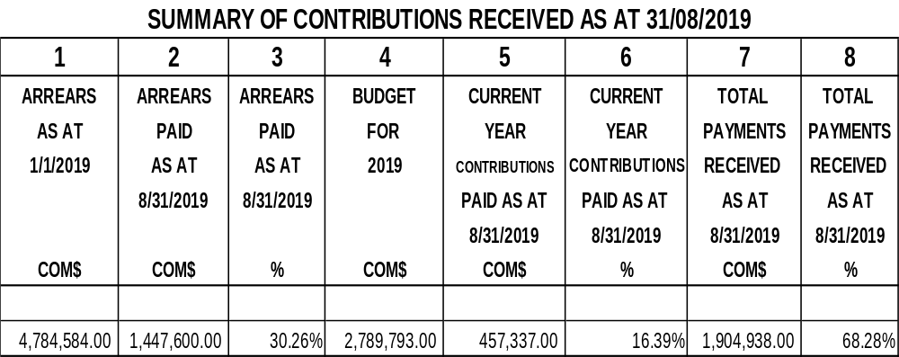
- Columns:

- Column 1 shows the total arrears that were due from Member States as at 1st January 2019;

- Column 2 shows the total arrears received as at 31st August 2019;

- Column 3 shows the total arrears received as a percentage of the total arrears;

- Column 4 shows the budget for 2019;

- Column 5 shows the 2019 assessed contributions received as at 31st August 2019;

- Column 6 shows the 2019 assessed contributions received as at 31st August 2019, as a percentage of the 2019 budget;

- Column 7 shows the total receipts from Member States as at 31st August 2019; and

- Column 8 shows the total receipts, as a percentage of the 2019 budget.

Analysis of status of Member States’ contributions

- Table III below shows in detail the status of all Member States’ contributions as at 31st August 2019 as follows:

- Egypt, Mauritius and Seychelles fully paid their 2019 assessed contributions;
- Somalia and Tunisia who joined the Membership of COMESA in 2018 have no previous budgetary obligations to the Court and, therefore, have only the 2019 assessed contributions outstanding;
- The Democratic Republic of Congo, Eritrea, Eswatini, Ethiopia, Kenya, Rwanda, Uganda and Zambia paid their contributions up to 2018;

- Malawi and Zimbabwe paid their contributions up to 2017;

- Djibouti paid her contributions up to 2014;
- Sudan effected payments in 2016 and these payments cleared Sudan’s arrears of several years up to 2013 and part of 2014. The payments were partly in form of actual transfer of funds and partly in form of credit advices. As of 31st August 2019, a total of COM$272,899 worth of credit advices were yet to be liquidated into actual cash transfers.
- Burundi paid her contributions up to 2013;
- Libya, whose current state is acknowledged, paid her contributions up to 2011;
- Comoros had arrears of several years and in 2014 she paid COM$15,699 towards her arrears; and
- Madagascar had a repayment plan approved by the COMESA Authority in 2016 as shown below:
- 2016 Fourth Quarter - COM$100,257.87;

- 2017 - COM$117,969.00;

- 2018 - COM$132,732.91; and

- 2019 - COM$190,974.22

- Since the approval of the repayment plan at the 2016 Heads of States’ Summit in Antananarivo, Madagascar has cleared her arrears up to 2017. Therefore, the Meeting is invited to note that Madagascar has fully complied with the repayment plan, and only arrears for 2018 and the 2019 assessed contributions remain outstanding.
Table III
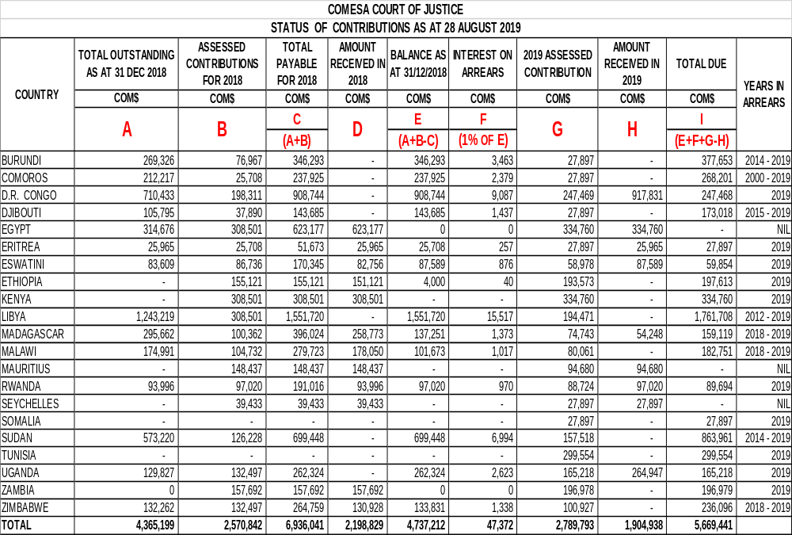
Aged analysis of arrears and current year Member States’ contributions as at 31st August 2019

- The Meeting is invited to note the aged analysis of Member States’ outstanding contributions as contained in Table IV below as follows:

- Egypt, Mauritius and Seychelles had no arrears;

- The Democratic Republic of Congo, Eritrea, Eswatini, Ethiopia, Kenya, Rwanda, Somalia, Tunisia, Uganda and Zambia have outstanding contributions of less than one year;

- Madagascar, Malawi and Zimbabwe have outstanding contributions and arrears of between two and one year; and

- Burundi, Comoros, Djibouti, Libya and Sudan have arrears of more than two years.

Table IV

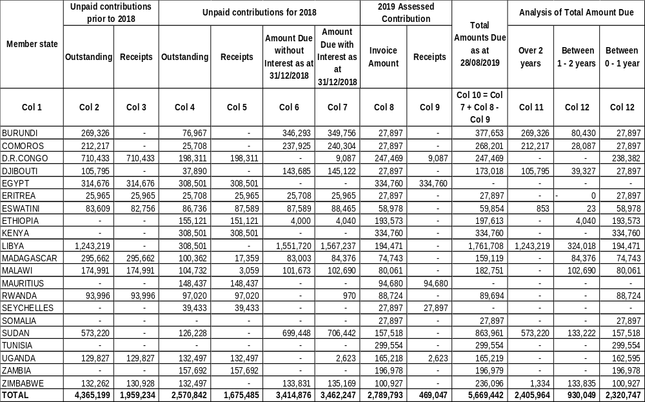
Observations on the Member States’ status of contributions to the 2019 Budget

- The COMESA Treaty provides that the budget of the COMESA Court of Justice shall be borne by Member States - Articles 42(2) and 166 (6) as follows:

“ARTICLE 42 of the COMESA Treaty provides that, – “The budget of the Court shall be borne by the Member States and that the formula for contributions to the budget for the Court shall be the formula applicable for the determination of contributions by Member States to the budget of the Secretariat.”

“ARTICLE 166 (6) states that fifty percent of the contributions for each Member State shall be paid into the budget of the COMESA Court of Justice within one month from the beginning of the financial year to which they relate, and the remainder shall be paid within six months from the beginning of the financial year.”

- While most Member States remitted their budgetary contributions to the Court towards the end of 2018, thereby generally improving the financial status of the COMESA Court at that time, most of the Member States are yet to remit their contributions to the 2019 COMESA Court of Justice Budget.

- The Meeting is invited to note that during the period under review, the Court received a total amount of COM$1,904,938. Out of this amount, only COM$457,337 was received towards the 2019 budget representing a 16.39% of the 2019 Budget of COM$2,789,793. The remaining balance of the total amount received in 2019 amounting to COM$1,447,600 was received towards arrears representing a receipt of 30.26% of arrears outstanding as at 1st January 2019 of COM$4,784,584.

- From the foregoing, remittances of budgetary contributions to the budget of the Court during the period under review has underperformed and this has implications on the performance of the Court. The non-payment of contributions by most of the Member States has the potential of undermining, in general, the achievement of the Court’s mandate and specifically the implementation of the Court’s 2019 Work Programme.

Recommendations

- It is recommended that:

- Egypt, Mauritius and Seychelles which had fully complied with the Treaty provisions on contributions by paying 100% of their obligations for 2019, be commended;
- Somalia and Tunisia who joined the Membership of COMESA in 2018 and have only the 2019 assessed contributions outstanding, be urged to clear their 2019 assessed contributions;

(b) The Democratic Republic of Congo, Eritrea, Eswatini, Ethiopia, Kenya, Rwanda, Uganda and Zambia which paid their contributions up to 2018, be commended and urged to clear their 2019 assessed contributions;

- Malawi and Zimbabwe which paid their contributions up to 2017 be commended and urged to clear their 2019 assessed contributions and arears for 2018;
- Djibouti which paid her contributions up to 2014 be urged to clear her 2019 assessed contributions and arears for the period 2014 to 2018;

- Sudan which effected payments in 2016 and cleared her arrears of several years up to 2013 and part of 2014, be commended and be urged to liquidate into cash transfers the balance of COM$272,899 which is still outstanding as credit advices on the account of the Court. Sudan be further urged to clear the remaining arrears and the 2019 assessed contributions;

- Madagascar be commended for proposing a repayment plan which was subsequently approved by the COMESA Authority in 2016, and for clearing her arrears up to 2017 and be urged to remit her arrears for 2018 and 2019 assessed contribution;

- Libya which paid her contributions up to 2011, and whose current state is acknowledged, be urged to pay her arrears and the 2019 assessed contributions;
- The Union of Comoros, which had arrears of several years be commended for paying part of her arrears and assessed contributions (year…?) and be urged to pay her remaining arrears and the 2019 assessed contribution;
- The Court should continue exploring new ways of following up on contributions payable by Member States;
- The Court, in consultation with Member States with arrears, should come up with proposals on how the concerned Member States could clear their arrears and current contributions; and
The Court should continue its endeavour to mobilise resources especially for technical assistance and capacity building.

- COMESA COURT OF JUSTICE EXPENDITURE BUDGET PERFORMANCE – 1ST JANUARY TO 31ST AUGUST 2019

- The 2019 total expenditure budget, whose details are contained in Tables V and VI, of COM$2,789,793, was approved by the Thirty Ninth Meeting of the Council of Ministers in November 2018 at Lusaka, Zambia.

Difficulties in Implementing the 2019 budget

- The Host Member State of the Court had experienced political challenges from around the end of 2018 to around the end of the first half of 2019. These challenges posed some operational as well as administrative difficulties for the Court. As a result, the smooth operations of the Court, including implementation of planned activities for 2019 were adversely affected. As a stop-gap measure, the Court took some administrative measures to ensure continuation of some of its activities particularly court sessions. The Court would like to report that, following the implementation of these measures, the Court was able to achieve a degree of business continuity despite the difficulties. The situation in the Host Member State has improved and continues to improve and as result, the Court’s operations have begun normalising to the level they were before December 2018.

- The Meeting is invited to recall that for years, the Host Member State has been under an economic embargo and these economic restrictions have also impacted on the operations of the Court. Thus, the Court has continued maintaining and carrying out some aspects of its financial management outside the Host Member State until the economic embargo is resolved.

Procurement of a standby electricity generator for the Court building

- The Court would like to report that the process for procuring a standby electricity generator for the Court building was finalised in 2018. Due to the technical nature of the equipment and field, the Court sought for technical assistance from the Secretariat. The Court would like to report that the Secretariat in 2018 did provide the assistance by seconding a Procurement Expert to the Court and recommending an electrical engineering Consultant who had undertaken similar assignments for the Secretariat. The Court would like to report that it has not yet finalised the procurement of the generator due to the difficulties occasioned by the economic embargo on the Host Member State and, the political challenges the Host Member State has faced in the recent past.

Procurement of a motor Vehicle

- The Council of Ministers at its Meeting in November 2018 at Lusaka, Zambia while considering the 2019 budget of the Court, considered and approved a request by the Court to purchase a motor vehicle. The Court would like to report that due to the difficulties occasioned by the economic embargo on the Host Member State and the political challenges that the Host Member State has faced in the recent past, the Court is yet to finalise the procurement of this motor vehicle.

Main activities undertaken by the court including challenges faced and remedial measures put in place in 2019

- The COMESA Court of Justice as at 31st August 2019, spent a total of COM1,413,200 representing a 51% utilisation of the total budget of COM$2,789,793. Tables V and VI below give details of the 2018 budget. Table V also compares the performance of the 2018 budget during the period under review with the 2018 budget. Further, Table V provides details of expected performance in the remaining period (September to December 2019) and additionally provides estimates of expected variances for 2019. Table VI analyses the performance of the 2019 budget by comparing the budget and the actuals for the period under review. The table also provides disclosures/notes on the differences between approved budget and actual amounts.

- The expenses for the period under consideration are mainly for Court Sessions and Meetings, trainings, publicity seminars and other operational expenses. The activities of publicity seminars and workshops in Member States and training for the Honourable Judges and members of staff of the Registry are being carried out as and when possible. So far, training for the Honourable Judges and members of staff has continued and the Court is planning to carry out at least one more publicity activity before the end of the year.

- The details of the main activities undertaken by the Court, challenges faced during the period under review and the remedial measures taken to mitigate the challenges during the period under review are summarised in Table VII below.

- The Court will continue implementing its 2019 Work Programme in line with its approved budget. Table VI below provides details of the expected activities and budget utilisation during the period September to December 2019. Table VI also contains notes explaining causes of variances between the approved budget and the actual expenditure during the period under review.

Use of budget line synergies and the benefits that have accrued as a result

- Synergy in management and in relation to teamwork refers to the combined effort of individuals as participants of the team. Synergy exists when the organisation's parts interact to produce a joint effect that is greater than the sum of the parts acting alone. A cost synergy refers to the opportunity of an entity to reduce or eliminate expenses associated with running it.

- In 2012 and 2013, the Court started implementing budget line leveraging or synergising between or among budget lines during budget implementation. This was done to enable the Court to maximise on the resources available. The measure was further geared towards mitigating the risk of low levels of remittances of budgetary contributions by Member States.

- Budget line leveraging has been achieved in several ways such as holding activities back–to–back. For example, when the Court is conducting a sensitisation activity in a given Member State, it combines that with other activities such as court sessions or administrative meetings. That way, the Court procures one air ticket for each Judge, yet the Judges carry out more than one activity.

- The budget line leveraging has abled the Court to conduct regular court sessions, meetings, sensitisation workshops/seminars and to meet its Human Resources and other obligations.

Recommendations

- It is recommended that the Court should:

- Continue implementing its 2019 Work Programme in line with the approved budget;

- Continue mobilising extra–budgetary resources to finance some of its activities;

- Expedite the finalisation of the procurement of the standby generator and motor vehicle once the constraints that have hindered the procurement ease up and, therefore, the Court be allowed to rollover the budgets for the standby generator and motor vehicle until such a time that the Court is able to finalise the purchase.
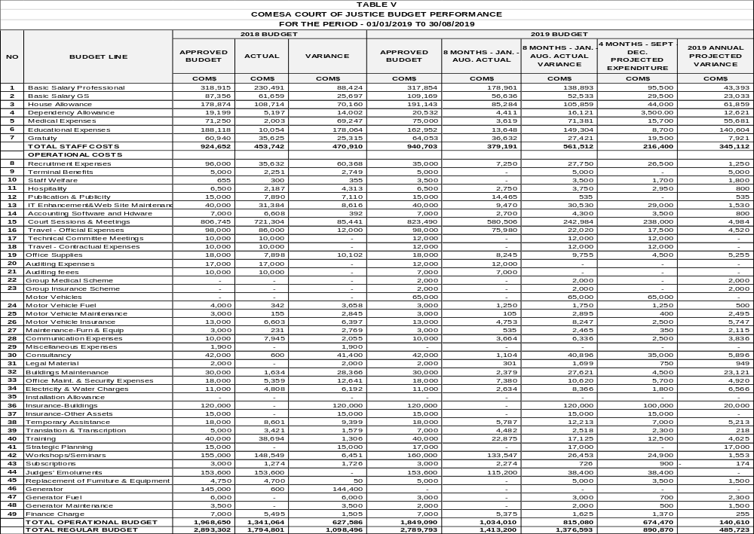
TABLE VI
STATEMENT OF COMPARISON OF APPROVED BUDGET AND ACTUAL AMOUNTS FOR THE PERIOD JANUARY - AUGUST 2019

BUDGET LINE DESCRIPTION | 2019 APPROVED BUDGET | JANUARY - AUGUST 2019 ACTUAL AMOUNTS | COMPARISON OF APPROVED BUDGET AND ACTUAL AMOUNTS |  |  | DISCLOSURES/NOTES ON THE DIFFERENCES BETWEEN APPROVED BUDGET AND ACTUAL AMOUNTS
BUDGET LINE DESCRIPTION | 2019 APPROVED BUDGET | JANUARY - AUGUST 2019 ACTUAL AMOUNTS | DIFFERENCE: BUDGET AND ACTUAL | DIFFERENCE: BUDGET AND ACTUAL | JANUARY - AUGUST 2019 ACTUAL AMOUNTS
BUDGET LINE DESCRIPTION | COM$ | COM$ | COM$ | % | %
Basic Salary Professional | 317,854 | 178,961 | 138,893 | 44 | 56 | Variances on these budget lines are due to the following factors: vacant positions of; two Administrative Assistants, Driver, Senior Finance Assistant, Internal Auditor and Clerk of Court. The Court has finalised the shortlisting and interviewing for the positions of Clerk of Court and Internal Auditor. The Administrative Meeting of the Court (the Board of the Court) will be meeting to consider and approve the recruitment report. The Positions of the two Administrative Assistants were filled in February and April this year although one of them is on temporary basis. The position of Receptionist and Switch Board Operator became vacant in April this year.
Basic Salary GS | 109,169 | 56,636 | 52,533 | 48 | 52
House Allowance | 191,143 | 85,284 | 105,859 | 55 | 45
Dependency Allowance | 20,532 | 4,411 | 16,121 | 79 | 21
Medical Expenses | 75,000 | 3,619 | 71,381 | 95 | 5
Educational Expenses | 162,952 | 13,648 | 149,304 | 92 | 8
Gratuity | 64,053 | 36,632 | 27,421 | 43 | 57
Staff Welfare | 3,500 | - | 3,500 | 100 | 0 | This budget is used for staff welfare expenses and used as and when there are staff welfare issues to address. During the period under review no staff welfare issues arose.
Recruitment Expenses | 35,000 | 7,250 | 27,750 | 79 | 21 | The remaining balance on this budget will be used in the finalisation of the recruitment of the Internal Auditor and Clerk of Court.
Terminal Benefits | 5,000 | - | 5,000 | 100 | 0 | This budget is used when staff separate from the Court and no separation expenses arose during the period under review.
Hospitality | 6,500 | 2,750 | 3,750 | 58 | 42 | The Court has been making some savings on some budget lines including this budget line through initiatives such as holding activities back-to–back. To enable the Court, achieve as much as possible from the available resources the Court has been implementing budget line leveraging and/or synergising between or among budget lines during budget implementation. For example, when the Court is conducting a sensitisation activity in one given Member State, it would combine that with other activities such as court sessions, administrative meetings amongst other activities. That way, for example, the Court would procure one air ticket for each Judge, but the Judges would carry out more than one activity.
Publication & Publicity | 15,000 | 14,465 | 535 | 4 | 96 | The balance on this will be utilised.
IT Enhancement & Web Site Maintenance | 40,000 | 9,470 | 30,530 | 76 | 24 | The Court, with the support from Microsoft, deployed and implemented an Evidence Management System (EMS) called CaseLines. The EMS was deployed and implemented in January 2019. The balances on these budget lines will be used in the finalisation of the implementation of this system by acquiring some hardware equipment such as laptops for Honourable Judges.
Accounting Software and Hardware | 7,000 | 2,700 | 4,300 | 61 | 39
Court Sessions & Meetings | 823,490 | 580,506 | 242,984 | 30 | 70 | The balance on this budget line will be utilised. The Court still has cases listed for hearing before the end of the year.
Travel - Official Expenses | 98,000 | 75,890 | 22,020 | 22 | 78 | The balance on this budget line will used during the remaining period of 2019. Among the activities that will be undertaken by the Court is the participation in the Policy Organs Meetings, Court Sessions and publicity activities.
Technical Committee Meetings | 12,000 | - | 12,000 | 100 | 0 | These budget lines will be fully utilised during scheduled statutory meetings and statutory contractual travels by members of staff before the end of the year.
Travel - Contractual Expenses | 12,000 | - | 12,000 | 100 | 0
Office Supplies | 18,000 | 8,245 | 9,755 | 54 | 46 | This is an office support budget line and the Court has made some savings by holding most of its activities such as court sessions and meetings outside its Seat.
Audit Expenses | 12,000 | 12,000 | - | 0 | 100 | These budget lines shall be utilised once audit activities for the 2019 financial year are completed.
Audit Fees | 7,000 | 7,000 | - | 0 | 100
Group Medical Scheme | 2,000 | - | 2,000 | 100 | 0 | These budget lines have not been utilised because of the economic embargo imposed on the Host Member State. During the period under review, the Court was unable to source for the insurance covers it had planned to obtain because of the restrictions occasioned by the economic embargo on the Host Member State and due to the situation, that has pertained at the Seat of the Court since December 2018.
Group Insurance Scheme | 2,000 | - | 2,000 | 100 | 0
Motor Vehicle | 65,000 | - | 65,000 | 100 | 0 | The budget line has not been utilised due to the difficulties occasioned by the economic embargo on the Host Member State and in the recent past, the political challenges the Host Member State has faced.
Motor Vehicle Fuel | 3,000 | 1,250 | 1,750 | 58 | 42 | These are support budget lines and because of the Court holding most activities away from its Seat in other Member States, it has made some savings on these budget lines.
Motor Vehicle Maintenance | 3,000 | 105 | 2,895 | 97 | 3
Motor Vehicle Insurance | 13,000 | 4,753 | 8,247 | 63 | 37 | The amount budgeted considers not only the premiums payable but also any excesses that would be levied in the event of an accident. It is worth noting that in such an eventuality, excesses payable would be calculated based on the market value of the motor vehicle and not the duty-free value at which the vehicles were purchased. During the period under review there were no accidents and therefore the Court did not have to settle any such excesses.
Maintenance-Furniture & Equipment | 3,000 | 536 | 2,465 | 82 | 18 | This budget line has not been fully utilised. The Court made some savings because most of the furniture and equipment are still in good working condition.
Communication Expenses | 10,000 | 3,664 | 6,336 | 63 | 37 | The balance on this budget line will used during the remaining period of 2019.
Consultancy | 42,000 | 1,104 | 40,896 | 97 | 3 | This budget line will be utilised. One of the activities the Court has slotted for implementation, and which will be financed from this budget line is the review of the terms and conditions of service for the Honourable Judges and a Human Resources needs assessment for the Court. The two activities are scheduled for advertising.
Legal Material | 2,000 | 301 | 1,699 | 85 | 15 | During the period under review, the Court still faced challenges occasioned by the economic embargo imposed on the Host Member State. It was difficult for example for the Court to acquire both hard and soft legal materials it needed because of the restrictions that come with the economic embargo and as a result, this budget has not been fully utilised.
Buildings Maintenance | 30,000 | 2,379 | 27,621 | 92 | 8 | These budgets have not been fully utilised due to the unresolved ownership status of the Court building. The Court has faced challenges in managing the building including any plans to commit and spend substantially on improvements and maintenance.
Office Maintenance & Security Expenses | 18,000 | 7,380 | 10,620 | 59 | 41
Electricity & Water Charges | 11,000 | 2,634 | 8,366 | 76 | 24 | This is a support budget line and due to the Court holding most of its activities outside its Seat some savings have been made on the budget line.
Insurance-Buildings | 120,000 | - | 120,000 | 100 | 0 | These budgets have not been utilised due to the unresolved ownership status of the Court building and the furniture and office equipment that were handed over by the Republic of Sudan to the Court. The Court has faced challenges in procuring insurance for the building and its contents due to this issue which is yet to be resolved.
Insurance-Other Assets | 15,000 | - | 15,000 | 100 | 0
Temporary Assistance | 18,000 | 5,787 | 12,213 | 68 | 32 | This budget line will be utilised. However, during the period under review the Court made some savings because of holding back -to-back activities. For example, combining travel for court sessions and other activities benefited from synergies between or among budget lines.
Translation & Transcription | 7,000 | 4,482 | 2,518 | 36 | 64 | This budget line will be utilised. The forthcoming Policy Organs Meetings require a lot of translation of reports and most of it will be financed from this budget line.
Training | 40,000 | 22,875 | 17,125 | 43 | 57 | The balances on these budget lines will be utilised. However, during the period under review, the Court made some savings because of holding back-to-back activities. For example, combining travel for court sessions and other activities benefited from synergies between or among budget lines. The Court has scheduled activities on strategy matters during the remaining period of 2019.
Strategic Planning | 17,000 | - | 17,000 | 100 | 0
Workshops/Seminars | 160,000 | 121,549 | 26,453 | 17 | 83 | The balance on this budget line will be utilised during the remaining period of 2019.
Subscriptions | 3,000 | 2,274 | 726 | 24 | 76 | The balance on this budget line will be utilised as the Court pays some of its subscription fees to institutions it is affiliated to.
Judges' Emoluments | 153,600 | 115,200 | 38,400 | 25 | 75 | This budget will be utilised.
Replacement of Furniture & Equipment | 5,000 | - | 5,000 | 100 | 0 | This budget will be utilised. The Court is procuring computer equipment for new members of staff.
Generator Fuel | 3,000 | - | 3,000 | 100 | 0 | The Court has not yet purchased the standby generator due to challenges occasioned by the economic embargo on the Host Member State and in the recent past, the political challenges that the Host Member State has faced.
Generator Maintenance | 2,000 | - | 2,000 | 100 | 0
Finance Charges | 7,000 | 5,375 | 1,625 | 23 | 77 | The balance on this budget line will be utilised. The Court is however making some savings because of holding most of its activities such as Court Sessions and Meetings back-to-back. Holding activities at the same time and venue brings about the benefit of making payments that cater for many activities. The Court also is fully utilising online banking services whose service charges are far lower than conventional banking service charges.
TOTAL REGULAR BUDGET | 2,789,793 | 1,413,200 | 1,376,593 | 49 | 51 | Despite the challenges being faced by the Court which were mainly occasioned by the economic embargo imposed on the Host Member State, and, in the recent past, the political challenges the Host Member State has faced, the Court, during the period under review, still managed to carry out most of its activities and managed to achieve an overall budget performance of 51%. As highlighted above, part of the 49% unutilised balance of the budget is as result of savings through initiatives such as holding activities back - to - back.

TABLE VII

SUMMARY OF MAIN ACTIVITIES UNDERTAKEN BY THE COURT INCLUDING CHALLENGES FACED AND REMEDIAL MEASURES PUT IN PLACE DURING THE PERIOD UNDER REVIEW

ACTITIVITIES COMPLETED | CHALLENGES | WAY FORWARD
- During the period under review, the Court held eight Court Sessions;  - The Court participated in the Extra Ordinary Policy Organs Meetings that were held in Lusaka, Zambia;  - For several years the Court has been searching for ICT solutions to automate Court processes as well as facilitate easy access of the Court’s services. The Court is glad to report that, with support from Microsoft, an Evidence Management System (EMS) called CaseLines was deployed. The EMS was deployed and implemented in January 2019;  - In March 2019, the Court conducted a retreat for Honourable Judges and senior Registry Staff. The purpose of the retreat was to appraise the Judges and staff on COMESA Treaty provisions, current and contemporary trade and economic developments within the COMESA Region and at the African Continental level;  - In March the Court, with the support of the Trade Law Centre (TRALAC) attended the TRALAC Annual Conference at which a wide range of Trade law and Policy issues were discussed, and the forum presented a training opportunity and exchange of experiences and knowledge to the Honourable Judges and Registry staff who attended the Conference;  - The Court in the last three years commenced the process of having some of its Judges and Senior Registry staff accredited to the Chartered Institute of Arbitration. This year between January and March, the Court finalised the accreditation process for three of its Judges and one of the Senior staffs of the Registry. The four are now Fellows of the Chartered Institute of Arbitration (FCIArb);  - In March 2019, the Court conducted a Training Session on Enterprise Risk Management - ERM for senior Registry Staff;  - In March/April 2019, the Court held a Publicity Seminar in Kampala, Uganda and the occasion was also used to launch a simplified Users Guide on how to access the services of the Court;  - The Court attended the Commonwealth Law Conference in Livingstone, Zambia at which the Court exhibited the services it offers to the Legal fraternity in the Commonwealth Region. The Court was also given a slot to make a presentation on the COMESA Court and the services that it offers;  - The Court jointly with the COMESA Competition Commission attended the Law Society of Kenya Annual Conference in Mombasa, Kenya at which the Court exhibited the services it offers to more than 1200 Lawyers from Kenya and the East African Region. The Court was also given a slot to make a presentation on the COMESA Court and the services that it has to offer;  - In April 2019, the Court participated in the African Arbitration Association Conference in Kigali, Rwanda at which a wide range of Arbitral issues were discussed., The forum presented further training opportunity and exchange of experiences and knowledge to the Honourable Judges and Registry staff who attended the Conference;  - In July 2019, the Court took part in the Source21 COMESA Trade Fair and High-Level Business Summit in Nairobi, Kenya;  - In July/August 2019, at London, United Kingdom, the Court in collaboration with Commonwealth Magistrates and Judges Association and the Civil Service College conducted a Training Session on Judicial Case Management & Ethics for some Honourable Judges and senior Registry Staff;  - The Court finalised the shortlisting and interviews for the positions of Clerk of Court and Internal Auditor. The Twenty Eighth Administrative Meeting of the Court to be held in September 2019 will consider the recruitment report. | - The Host Member State of the Court has experienced political challenges from around the end of 2018 to around the end of the first half of 2019. These challenges posed some operational as well as administrative difficulties for the Court. The smooth operations of the Court were, as a result, adversely affected. This included implementation of planned activities for 2019.  - Delay or non-remittance of budgetary contributions by some Member States;  - Inadequate staff to support implementation of the planned work programme;  - There are still not enough Cooperating Partners coming forward to support the Court in its programmes;  - Non-availability of genuine software and hardware applications due to the economic embargo on the Host Government;  - Impact of economic sanctions imposed on the Host Member State on the operations of the Court;  - Delay by the Host Government to resolve the issue of the title deeds for the Court building and other handover documents for the other assets handed over to the Court;  - The constraint to carry out most operations of the Court away from its permanent seat due to the economic embargo on the Host Member State;  - Inadequate ICT systems to meet the Court’s requirements. | - In the wake of the political challenges that were experienced by the Host Member State, the Court instituted administrative measures to ensure continuation of some activities particularly court sessions. The Court would like to report that following implementation of the administrative measures, the Court carried out some activities as indicated in the column on the left of this Table. The situation in the Host Member State has improved and continues to improve. As a result, the Court’s operations have begun normalising.  - Continue exploring other means of mobilising contributions from Member States;  - Carry out review of human resources organisational structure needs of the Court;  - Continue with the use of temporary assistance including seeking assistance from the Secretariat in implementing some of the Court’s work programmes;  - Continue with efforts to identify more Cooperating Partners who could support the Court;  - Continue using software and hardware that are not affected by the economic embargo; and  - Continue maintaining and carrying out some aspects of financial management outside the Host Member State until the economic embargo is resolved.

