COMMON MARKET FOR EASTERN AND
SOUTHERN AFRICA

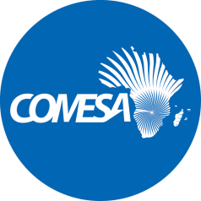

DRAFT DUMMY REPORT

2017 Audited Financial Statements

Project Name:COMESA-Airspace Integration Project

Source of Funding:AFDB

Grant Utilization Summary | Currency
Grant Amount | USD 8.6M
Grant utilized before current year | USD 3,062,840
Grant utilized in 2017 | USD 807,160
Balance -2017 | USD3,646,382

––––––––––––––––––––––––––––––––––––––––––––––––––––––––––––––––––––––

- The Sub Committee is invited to consider the 2017 Audited Financial Statements and accompanying Management Letter issued by the external auditors KPMG Lusaka Zambia. The period covered is from 1 January to 30th December 2017
- The Sub Committee is also invited to consider the following:

  - Audit Opinion

“Report on the audit of the financial statements

Opinion
We have audited the financial statements of COMESA – Air Space (“the Project”), which comprise the statement of financial position as at 31 December 2017, the statements of income and expenditure and cash flows for the year then ended, and notes to the financial statements, including a summary of significant accounting policies and other explanatory information as set out on pages 8 to 23.

In our opinion, the financial statements present fairly, in all material respects, the financial position of COMESA – Airspace Integration Project as at 31 December 2017 and its financial performance and its cash flows for the year then ended in accordance with International Financial Reporting Standards, the requirements of the COMESA financial rules and regulations and the protocol of agreement between COMESA and African Development Bank.

  - Management Letter

Finding | Recommendations | Action taken | Status  31 August 2019 | Completion Time frame
N/A

- Discussion

[To be completed at the meeting]

- Decision

The Sub Committee is invited to:

- recommend that the unqualified 2017 Audited Financial Statements of COMESA-Airspace Integration Project be considered by the Committee on Admin and Budgetary Matters.

