COMMON MARKET FOR EASTERN AND
SOUTHERN AFRICA

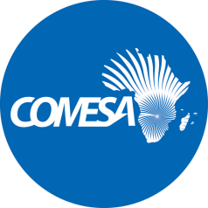

DRAFT DUMMY REPORT

2017 Audited Financial Statements

Project Name: Technical Co-operation Facility 11th EDF Programme

Source of Funding: European Union (EU)

Grant Utilization Summary | Currency (Euro)
Grant Amount | 2,021,080
Grant utilized before current year | 12,584
Grant utilized in 2017 | 493,125
Balance -2017 | 1,515,371

––––––––––––––––––––––––––––––––––––––––––––––––––––––––––––––––––––––

- The Sub Committee is invited to consider the 2017 Audited Financial Statements and accompanying Management Letter issued by the external auditors (PricewaterhouseCoopers). The period covered is from August 2016 to December 2017

- The Sub Committee is also invited to consider the following:

  - Audit Opinion

“In our opinion, the financial statements of the Technical Co-operation Facility 11th EDF Programme (the” Programme”) for the period from 8 August 2016 to 31 December 2017, are prepared in all material respects, in accordance with the basis of accounting described in Note 2 to the financial statements.”

  - Management Letter

Finding | Recommendations | Action taken | Status  31 August 2019 | Completion Time frame
N/A

- Discussion

[To be completed at the meeting]

- Decision

The Sub Committee is invited to:

- recommend that the unqualified 2017 Audited Financial Statements of (Technical Co-operation Facility - 11th EDF Programme) be considered by the Committee on Admin and Budgetary Matters.

- urge the Secretariat to expedite implementation of audit findings. A progress report will be availed to the Sub Committee at its next meeting.

