COMMON MARKET FOR EASTERN AND
SOUTHERN AFRICA

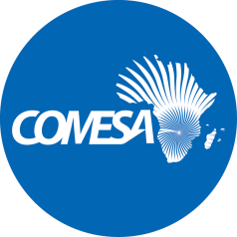

DRAFT DUMMY REPORT

2017 Audited Financial Statements

Project Name: 11th EDF Enhancement of a Sustainable Regional Energy Market in Eastern Africa-Southern Africa-Indian Ocean (ESREM EA-SA-IO) Region Programme

Source of Funding: European Union

Grant Utilization Summary | Currency (Euro)
Grant received from EU in the period | 1,780,665
Grant utilized before current year | -
Grant utilized in 2017 | (94,889)
Balance -2017 | 1,685,776

––––––––––––––––––––––––––––––––––––––––––––––––––––––––––––––––––––––

- The Sub Committee is invited to consider the 2017 Audited Financial Statements issued by the external auditors PricewaterhouseCoopers. The period covered is from 01 June 2017 to 31 December 2017.

- The Sub Committee is also invited to consider the following:

  - Audit Opinion

“In our opinion, the financial statements of the 11th EDF Enhancement of a Sustainable Regional Energy Market in Eastern Africa-Southern Africa-Indian Ocean (ESREM EA-SA-IO) Region Programme (the “Programme”) for the 7 month period from 1 June 2017 to 31 December 2017 are prepared in all material respects, in accordance with the accounting policies described in Note 2 to the financial statements.”

- Discussion

[To be completed at the meeting]

- Decision

The Sub Committee is invited to:

- recommend that the unqualified 2017 Audited Financial Statements of 11th EDF Enhancement of a Sustainable Regional Energy Market in Eastern Africa-Southern Africa-Indian Ocean (ESREM EA-SA-IO) Region Programme be considered by the Committee on Admin and Budgetary Matters.

