COMMON MARKET FOR EASTERN AND
SOUTHERN AFRICA

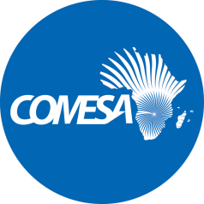

DRAFT DUMMY REPORT

2017 Audited Financial Statements

Project Name:COMESA- Trading for Peace

Source of Funding:African development bank (AfDB)

Grant Utilization Summary | Currency
Grant Amount | 692,100
Grant utilized before current year | 540,475
Grant utilized in 2017 | 117,658
Balance -2017 | 33,967

––––––––––––––––––––––––––––––––––––––––––––––––––––––––––––––––––––––

- The Sub Committee is invited to consider the 2017 Audited Financial Statements and accompanying Management Letter issued by the external auditors (KPMG Lusaka Zambia). The period covered is from 1 January to 31st December 2017

- The Sub Committee is also invited to consider the following:

  - Audit Opinion

“Report on the audit of the financial statements

Opinion
In our opinion, the financial statements that give a true and fair view of the financial position of COMESA – Trading for Peace Project as at 31st December 2017 and its financial performance and its cash flows for the year then ended in accordance with International Financial Reporting Standards, the requirements of the COMESA financial rules and regulations and the Protocol of Agreement between COMESA and African Development Bank.

2.2 Management Letter

Finding | Recommendations | Action taken | Status  31 August 2019 | Completion Time frame
N/A

- Discussion

[To be completed at the meeting]

- Decision

The Sub Committee is invited to:

- recommend that the unqualified 2017 Audited Financial Statements of (COMESA- Trading for Peace) be considered by the Committee on Admin and Budgetary Matters.

- urge the Secretariat to expedite implementation of audit findings. A progress report will be availed to the Sub Committee at its next meeting.

