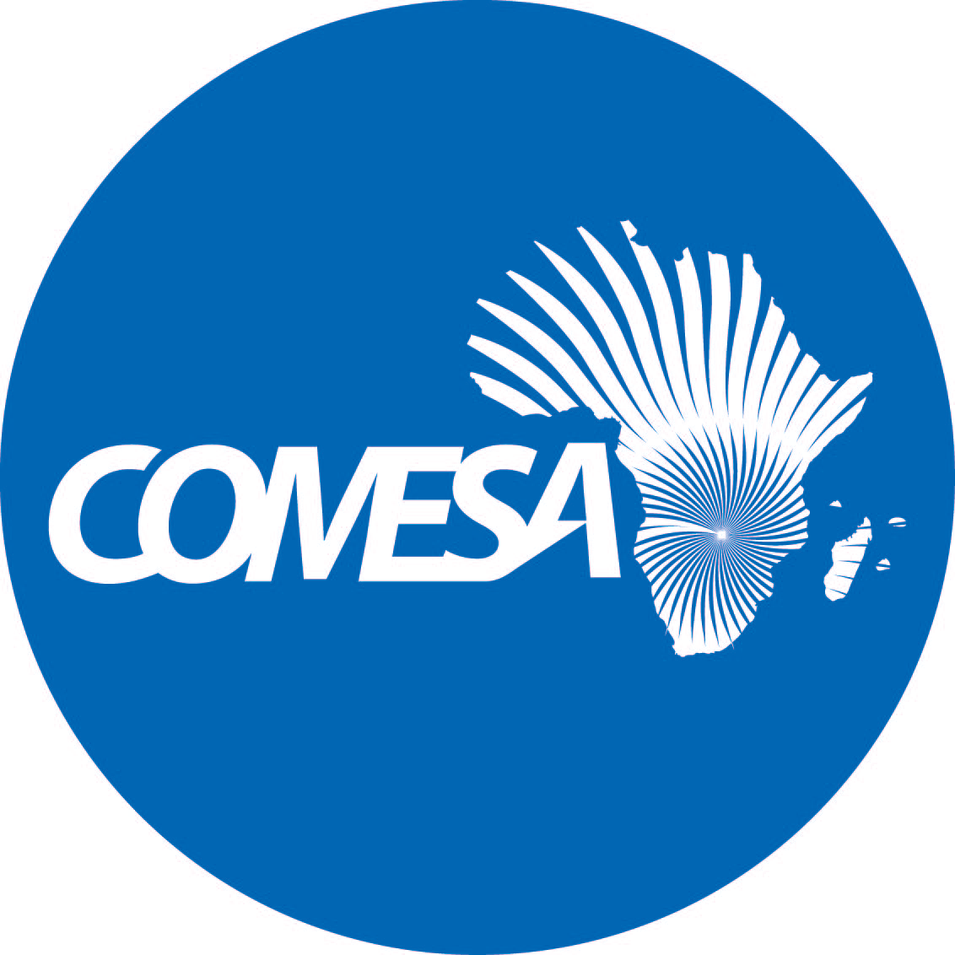
Distr. RESTRICTED

October 2019

Original: ENGLISH

COMMON MARKET FOR EASTERN
AND SOUTHERN AFRICA

Twenty Second Meeting of the Sub-Committee on Audit and
Budgetary Matters

Lusaka, Zambia
28th – 30th October 2019

INTERIM ARRANGEMENTS TO INCORPORATE COMESA GOVERNANCE PEACE AND SECURITY IN REGULAR COMESA STRUCTURE

EM (19)
CONTEXT

- The Thirty Ninth Meeting of the Council of Ministers Meeting, which was held in Lusaka in November 2018 approved the allocation of US$364,292 for staffing of staff of the Governance, Peace and Security Unit, specifically the Head of Unit, two analysts and a finance officer. This was done in response of a directive of the 20th Summit of the COMESA Authority, which was held in Lusaka, Zambia on 18th – 19th July 2018. Specifically, the Authority directed the Member States to implement previous directives to provide resources and structures that support the building of the African Peace and Security Architecture (APSA); and the COMESA Secretariat to incorporate in its 2019 budget, staffing required to implement the APSA Work Programme, whilst work towards finalization of the Secretariat Organizational structure is in progress.

- The Ministers further directed the Secretary General to engage the EU with the view of financing staff costs of the remaining three key APSA staff, namely Early Warning Expert/Post Conflict Reconstruction and Development, Early Warning Analysts and the COMESA Liaison Officer in Addis Ababa.

- In response to the directive, all key APSA staff were retained in 2019:
  - US$334,210.25 was drawn from the overhead contribution to the Secretariat to support four staff members, and
  - The EU through the TCF extended US$266,261.26 to finance the remaining three staff members.

- The contracts for all GPS staff members are due to expire in December 2019 and several factors have made it necessary for the Secretariat to make a request for allocation of funds to support GPS staff in 2020
  - The anticipated review of the Organizational Structure has not been completed yet and therefore GPS staff are still not covered in the COMESA Structure;
  - The development of the next phase of APSA is still underway, and the staff from GPS are developing the programme document as well as negotiating the additional funding for programmes expected to run from January 2020 to 2023.
  - The EU delegation in Lusaka had provided funding for staff in 2019 with the understanding that the Secretariat will progressively absorb the three staff members in its structure.

- This paper indicates that US$ 600,471.51 shall be required, on an interim basis towards the implementation of this decision. This will enable the COMESA to secure and absorb APSA grant funding for 2020 – 2023.

- The proposed interim staffing shall also allow the Secretariat to complete the process mobilizing APSA 4 resources and ensure a smooth transition of the APSA programme in 2020; support the implementation of the other Governance, Peace and Security Programmes and functions, in particular, servicing the COMESA Policy Organs that deal with matters of peace and security, implementation of the Regional Maritime Security Programme, the Consolidation of democracy through the observation of elections over the same period and supporting the implementation of a joint COMESA-AGA project supporting youth engagement in democratic governance.

INTRODUCTION

Overview

- The paper is done in response a Decision of the 16th Meeting of the COMESA Ministers of Foreign Affairs which was endorsed by the Twentieth Summit of the COMESA Authority directing COMESA to incorporate Governance Peace and Security staff members to the regular COMESA budget. Specifically, the decisions read,

- Recall a decision of the Tenth Meeting of the Ministers of Foreign Affairs, which called on member states to provide resources for structures and projects that support the building of APSA and urge for the implementation of the Decision.
- Direct the Secretariat to review the structure of its organization with the view of ensuring its efficiency with respect to the use of its resources as well as its sustainability; and to thus use the outcomes of this exercise to include in its next budget, and provide alternatives for salaries of staff members that will enable the continuation of the Programme

- The continued implementation of the directive remains urgent because donors that previously funded staff in Regional Economic Communities (RECs) have started to implement their revised funding modalities away from funding staff costs. This includes the European Union, which has redirected its funding to RECs implementing APSA exclusively for activities and programmes of the RECs. The EU has been the largest supporter of staff costs of the GPS unit in the past until 2018.

Expected funding related to GPS activities in 2020

- The programme is anticipating implementing programmes of at least US$ 2.8 Million in 2020 as shown in the table below. The actual funding that COMESA will receive from APSA will be clear during the APSA Steering Committee meeting, scheduled for November 2019. It is thus herein assumed that COMESA will be allocated the same funding as its 2019 Budget of approximately US$ 0.9 Million. In addition, the programme is implementing the regional maritime security programme will run to 2020. There are discussions for an additional funding to be allocated to MASE (but this is not factored into the calculations below as the discussions are still in progress). The Programme is also working in close collaboration with the Gender and Social Affairs Division to implement a joint COMESA-AGA programme to support the engagement of youth in democratic governance and social economic development.

ACHIEVEMENTS 2019 AND KEY RISKS

Overview and Key Achievements

- Several achievements were made by the programme during the period that COMESA extended funding to GPS staff in 2019. This include, inter-alia.,
  - Developed and disseminated structural vulnerability reports to a wide range of sectors in Member States as well as trained 30 officials from Kenya, Madagascar, Zimbabwe, Zambia and Uganda on the COMESA Early Warning System (COMWARN). COMESA worked in close collaboration with the AU and used the training of trainer’s workshops to build capacity of the AU Country Structural Vulnerability and Resilience Assessments process. It is expected that Member states will engage these two processes (COMESA and AU) to ultimately enhance their resilience (the COMESA target is peace and prosperity).
  - Developed a comprehensive Mediation Strategy for COMESA, which includes, Guidelines on the Mediation Process a Handbooks on mediation for electoral conflicts and a Handbook on mediation for natural-resource based conflicts. This is intended to be tested in a Member State and disseminated widely to build member state capacity to address conflicts. The programme also developed a comprehensive resource package for conflict early warning that will be made available to member states.
  - Improved the working conditions of small-scale cross border traders in countries of the Great Lakes Region by training and sensitizing over 120 small scale traders, members of Cross Border Traders Associations and border officials trained on minimum standards for treating cross border traders through border workshops held in Zambia, Uganda Congo and Rwanda. In addition, COMESA continued to support Trade Information Desk (TIDs) through payment of allowances to the TIDO’s
  - Supported the mobilization of resources from the Swedish Development Agency as well as commencement of the implementation of a joint programme with the African Governance Architecture (AGA). The Joint COMESA-AGA project on youth engagement in democratic governance and socio-economic development processes in Africa commenced implementation in 2019.
  - Under the MASE programme, COMESA supported Ethiopia FRC to join the Egmont Group of FIUs, which will provide the FRC numerous capacity building opportunities as well as access to information sharing in a secured communications platform; developed a numeric platform for Madagascar Anti-Money Laundering/ Combating Financing of Terrorism (AML/CFT) Stakeholders to enhance internal information sharing; supported mutual evaluation exercises for Seychelles and Tanzania that will lead to strengthening of their respective AML/CFT regimes; supported the commencement of National Risk Assessment on ML/TF for Comoros, intended to help in priorisation and allocation of resources for AML/CFT; supported the review and amendment of AML/CFT laws in several countries and training of stakeholders among other things.

Key Risks for COMESA

- Given that funding from the EU for staff is not guaranteed, it is expected that if funding is not availed from COMESA Budget for GPS Staff in 2020, the following could be risks for COMESA:
  - APSA is preparing to launch its fourth phase (APSA 4) for which funding for COMESA is guaranteed as was in the previous phases. This requires active participation of the RECs to provide and defend action documents and proposals to access the funds. In the past COMESA has been able to mobilize an average of US$ 1.08 per month (annex 1). Without GPS staff, COMESA will be unable access or implement future APSA-funded activities thus not participate in the next phases of APSA.
  - COMESA will find it difficult to access additional funds from other cooperating partners to implement programmes. COMESA is looking forward to commencing discussions with AfDB to support a second phase of PCRD activities under the Trading for Peace programme. The existence of key staff at this early stage is therefore crucially important. The programme has demonstrated its ability to mobilise as well as manage resources. The potential risk can be estimated as US$ 1.85 Million
  - The smooth implementation of the GPS programmes such as MASE as well as the Joint COMESA-AGA programme could be adversely affected. COMESA is implementing a Maritime Security Programme funded by EU. Its implementation is guided by the Head of GPS who was instrumental in its development and who commits at least 40% of her time ensuring the effective implementation of the programme. Loss of GPS staff will put approximately 0.9 Million at risk. GPS is also working in close collaboration with the Gender division, providing guidance on matters relating to democratic governance which will thus also be affected.
  - Without staff in the unit, COMESA will have difficulty fulfilling its mandate to provide technical support to Member States including support in servicing statutory policy organ meetings (Committee on Peace and Security and Ministers of Foreign Affairs meetings); as well as observation of elections;
  - COMESA stands to lose on the gains made in developing a robust early warning system and strengthening of the mediation capacity of the COMESA Committee of Elders, among others; as well as skills developed by the staff over the years in the programme

IMPLEMENTATION OF THE AUTHORITY DECISION – STAFFING TOWARDS PEACE AND SECURITY PROGRAMMES

- To ensure effective implementation, it is proposed that for 2020:
  - COMESA continue to support the four staff members it supported in the 2019 Budget, specifically, the Head GPS, two early warning analysts and the finance officer for APSA from the same envelop, the overhead contribution budget line.
  - Support also, from the same budget line, the three staff members that were supported by the EU in 2019, namely the Conflict Early Warning Expert who is also supporting PCRD, the Data analyst that is also supporting Mediation programme and the Liaison Officer at the AU.

- The cost overlay for these proposals is as follows:

RECOMMENDATIONS

- The Sub-Committee is invited to consider the following recommendations:
  - Direct the Secretariat to incorporate, on an interim basis, GPS staff in to the regular COMESA Budget for 2020 from the Overhead Contribution Budget line;
  - Commend the Secretary General for the efforts that lead to support of three GPS staff members by EU in 2019 and Urge her to continue to engage the EU to consider extending this support to the three into 2020.

