Project: Assistance to draft the COMESA Framework for sustaining and enhancing COMESA’s compliance with 7 pillar standards, specifically focusing on assurance requirements

Introduction
Following the report of the Select Committee and the Council’s meeting on 5 April 2019, the Council decided that a “Framework for oversight and governance over external audits that will assist in the organization and help to preserve that standards in respect of external assurance processes are met by all relevant stakeholders.”

In this context, EY has been selected to assist COMESA Secretariat to develop such framework.

Objective
The Framework will guide on the following:
- The relationship between the auditee and all the auditors, specifically the following: -
- Auditors engaged by the Council under Article 169 (2); and
- Auditors engaged by Cooperating Partners under individual grant contracts.
- The to be played by the Sub Committee on Audit and Budgetary Matters, specifically as required by: -
- Article 169 (4) of the COMESA Treaty;
- Best practice and international standards in the framework of advising and enabling “those charged with governance, be it at policy and or technical levels” to effectively fulfil their mandate; and
- Adequacy of both financial reporting and external auditing processes.
- Interaction of the Sub Committee on Audit and Budgetary matters, with external auditors to ensure compliance with requirements of IESBA, as well as, provision laid down in the COMESA Treaty.

Approach
A 3 phases approach will be adopted as follows:
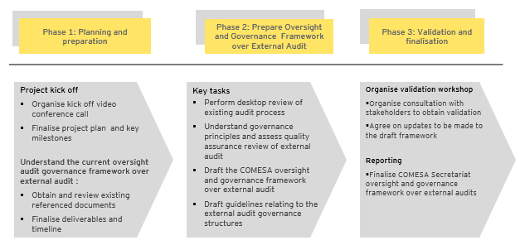
During our work, we will review the existing documents which we have received. We will consider international standards such as: (1) International Ethics Standards Board for Accountants (IESBA), (2) International Accounting Standards Board (IASB) and (3) International Standards on Auditing (ISA) and International Standard for Supreme Audit Institutions (ISSAI).

Deliverables and Supervision
EY will submit a draft COMESA Oversight and Governance Framework by the end of October 2019.

