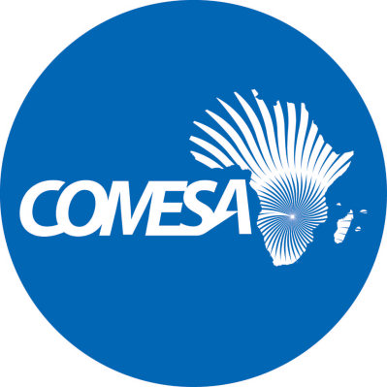

Distr.
RESTRICTED
CS/ADC/XL/1(Rev1)
November 2019
Original: ENGLISH

COMMON MARKET FOR EASTERN
AND SOUTHERN AFRICA

Fortieth Meeting of the Committee on
Administrative and Budgetary matters

Lusaka, Zambia
13 – 15 November 2019

PROVISIONAL AGENDA

THEME: COMESA - Towards Digital Economic Integration

- Opening of the Meeting

  - Introductory Remarks by the Secretary General
  - Adoption of Agenda and Organisation of Work

- Administrative and Human Resource Matters

  - Report on Renewal of professional Staff Employment Contracts
  - Report of Staff Recruitment into Professional Posts
  - Progress Report on COMESA Secretariat Organisational Structure

- Consideration of the Report of the Technical Committee on the COMESA Headquarters

- Consideration of the Report of the 22nd Meeting of the Sub Committee on Audit and Budgetary Matters

- Any other business

- Adoption of Report

