PRESS RELEASE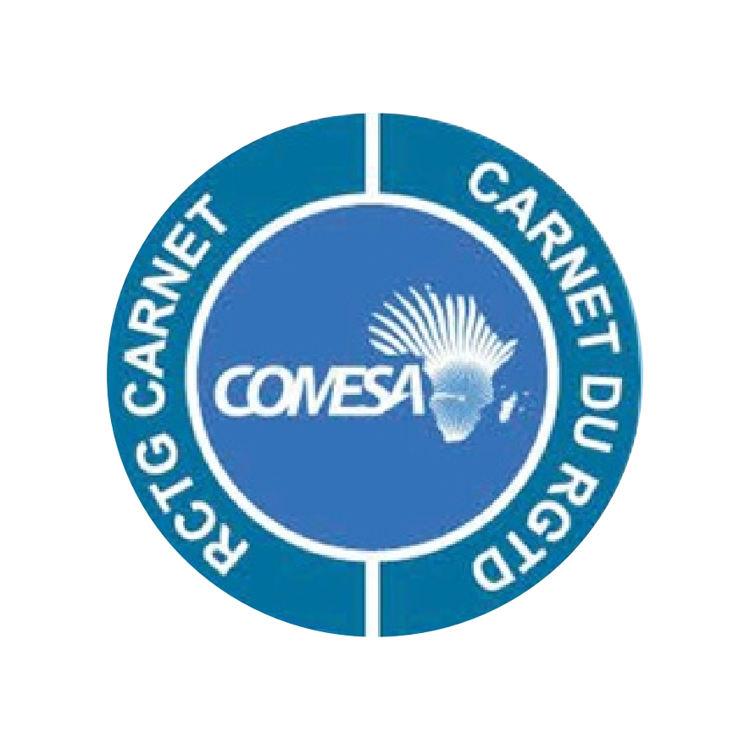

COMESA Launches Regional Customs Transit Guarantee Scheme Mobile App.

Lusaka, Friday, 11th September 2020 – The COMESA Regional Customs Transit Guarantee Scheme (RCTG Carnet) has launched a Mobile Application designed to provide access to real-time information to Clearing and Forwarding Agents.
The Application which is accessible on Google Play Store and Apple Store is a one-stop shop that will allow Clearing and Forwarding Agents in member countries to view current bond balance and active Carnets, get notifications on Carnet acquittals and expiry of RCTG Bonds.
Carnet is a Guarantee document that is used throughout the transit process as a proof of a valid Guarantee/Bond and an undertaking to comply with Customs obligations within each transit country.
The RCTG Scheme is a customs transit regime developed to facilitate the movement of goods under customs seals in the COMESA region. It provides the required customs security and guarantee to the transit countries. Among its key benefit is the reducing the cost of Bond /Guarantee and collaterals charged by Sureties and agents.
“I certainly believe that the creation of this Mobile Application is a very practical way of enabling Clearing and Forwarding Agents to access real-time information on their RCTG bonds from wherever they are without going through Customs Authority offices”, Secretary General Chileshe Kapwepwe said.
COMESA RCTG Carnet is the second of its kind in the world after the European Transports Internationaux Routiers (TIR) Carnet and the only one in the region and continent. It is recognized by the World Customs Organization (WCO).
The RCTG Scheme has 13 members namely: Burundi, Djibouti, DR Congo, Ethiopia, Madagascar, Malawi, Kenya, Rwanda, South Sudan, Sudan, Tanzania, Uganda and Zimbabwe. Currently, the Scheme is operational in five countries; namely: Burundi, Kenya, Rwanda, Tanzania and Uganda. The RCTG Carnet is fully digitalized and integrated with the National Customs IT Systems.
During the year 2018 nearly $2billion COMESA RCTG Carnet (guarantee) for customs duty and taxes for goods in transit in the Northern and Central Corridor countries were issued. Find the App on google and apple store on:- https://play.google.com/store/apps/details?id=com.comesa.rctgmobile https://apps.apple.com/us/app/id1530035067#?platform=iphone
Contacts:- Mr Berhane Giday, Head of RCTG: rctg@comesa.int or
Muzinge Nampito, Corporate Communications, mnampito@comesa.int
Follow us on: Website: www.rctg.comesa.int Twitter: https://twitter.com/comesa_lusaka
Facebook: https://www.facebook.com/ComesaSecretariat/

