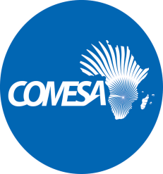
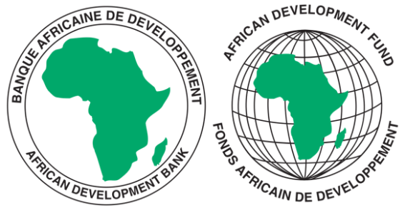
COMMON MARKET FOR EASTERN AND SOUTHERN AFRICA
SPECIFIC PROCUREMENT NOTICE
(INVITATION TO BID)

IFB Number: CS/AFDB/PROC/008/25-SM/km
Purchaser: Common Market for Eastern and Southern Africa (COMESA)
Project: COMESA Support towards Regional Pharmaceutical Development (CSTRPD) Project
Contract title: Supply, Delivery, Installation and Commissioning of Laboratory Testing Equipment including Training of End Users.
Country: Multinational
Loan No. / Grant No.: 2100155042033
Procurement Method: International Competitive Bidding (ICB)
ICB No: CS/AFDB/PROC/008/25-SM/km
Issued on: 21st November 2025

- The Common Market for Eastern and Southern Africa (COMESA) has received financing from the African Development fund hereinafter called the Bank toward the cost of the COMESA Support Towards Regional Pharmaceutical Sector Development (CSTRPSD) Project and intends to apply part of the proceeds toward payments under the contractfor Supply, Delivery, Installation and Commissioning of Laboratory Testing Equipment, Including Training of End Users. For this contract, the Borrower shall process the payments using the Direct Payment disbursement method, as defined in the Bank’s Disbursement Guidelines and procedures for Investment Project Financing, except for those payments, which the contract provides to be made through letter of credit.

- COMESA now invites sealed Bids from Eligible Bidders for the Supply, Delivery, Installation and Commissioning of Laboratory Testing Equipment, Including Training of End Users to be delivered at various sites within 6-8 weeks from the date of signature of contract by the last party.

- “Bidders may Bid for one or more Items, Lots or Packages, as applicable and, as further defined in the bidding document. Bidders wishing to offer discounts in case they are awarded more than one Items, Lots or Packages as applicable will be allowed to do so, provided those discounts are included in the Letter of Bid.”
4. Bidding will be conducted through the Open Competitive Bidding (International) (OCBI) method as specified in the Bank’s Procurement Framework² Policy and Methodology for Bank Group Funded Operations, dated October 2015, which can be found at the following website: www.afdb.org., and is open to all eligible bidders as defined in the Procurement Framework.

5. Interested eligible Bidders may obtain further information from the Procurement Unit, COMESA Secretariat, Contact Person: Mr Kondanani Miti, Procurement Expert, COMESA. E-mail: kmiti @comesa.int with a Copy to Mr. Silver Mwesigwa at Email silver.mwesugwa@comesa.int

6. The bidding document in English may downloaded free of charge from the COMESA
Website on the link alongside this notice: www.comesa.int

7. Bids must be delivered and deposited in the tender box located at the procurement Unit, COMESA Secretariat on or before 30th January 2026 at 10:00 Hours, Lusaka time. Late Bids will be rejected. Bids will be publicly opened in the presence of the Bidders’ designated representatives and anyone who chooses to attend soon after the deadline for submission.
8. All Bids must be accompanied by a Bid Security in form of a Bank Guarantee in the amounts as shown below:
(a) Lot 1 (Burundi) - US$4000, (b) Lot 2 (Kenya) - US$6000, (c ) Lot 3 ( Uganda) - US$2000, (d) Lot 4 ( Zambia) – US$8000 and ( e) Lot 5 (Zimbabwe) - US$8000
9. Attention is drawn to the Procurement Framework requiring the Borrower to disclose information on the successful bidder’s beneficial ownership, as part of the Contract Award Notice, using the Beneficial Ownership Disclosure Form as included in the bidding document.
10. The address(es) referred to above is (are):
Mr Silver Mwesigwa
Head of Procurement
Common Market for Eastern and Southern Africa
Ground Floor, COMESA Centre, Ben Bella Road,
P.O. Box 30051, Lusaka – Zambia,
Telephone: +260 211 2297226/29.
Web: http://www.comesa.int
Facsimile : +260 211 227318
Email : kmiti@comesa.int; copy to : procurement@comesa.int and
silver.mwesugwa@comesa.int

