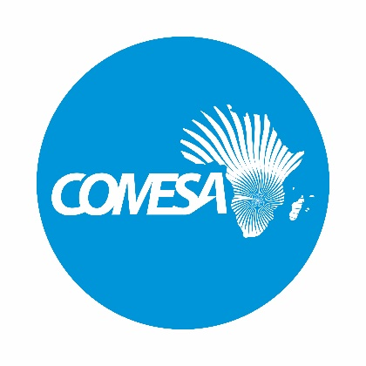

PRESS STATEMENT

Signing Of The Kenya – Uganda Mutual Recognition Agreement For Conformity Assessment

Lusaka, Zambia Thursday 4 December 2025: – The Common Market for Eastern and Southern Africa (COMESA) is pleased to announce the signing of the Mutual Recognition Agreement (MRA) on Conformity Assessment between the Republic of Kenya and the Republic of Uganda. This significant milestone took place on the sidelines of the COMESA Council of Ministers meeting on 4 December 2025, in Lusaka, Zambia.

The MRA is a key outcome of the “Enhancing Regional Agricultural Commodity Trade in COMESA” project, which aims to promote regional trade by reducing technical barriers and enhancing the recognition of conformity assessment procedures (e.g. inspection and sampling, testing, certification) between Member States. The project, supported by the Alliance for a Green Revolution in Africa (AGRA) and the Foreign, Commonwealth and Development Office (FCDO), covers six key traded commodities in the region, namely maize, groundnuts, soybeans, rice, beans, and sorghum.

This agreement will enable Kenya and Uganda to recognize each other's conformity assessment procedures, reducing the need for duplicate testing and certification of goods. This will lead to increased trade, competitiveness, and economic growth, particularly for Small and Medium-Sized Enterprises (SMEs) that are critical to the region's economic development.

The signing ceremony was witnessed by the COMESA Secretary General and has signatures of Hon. Lee Kinyanjui, Cabinet Secretary, Ministry of Investments, Trade and Industry of Kenya and Hon. Francis Mwebesa, Minister of Trade, Industry and Cooperatives of Uganda.

This milestone builds on the progress made so far under the project, including the signing of the Malawi – Zambia MRA in August 2025 and the completion of technical negotiations for MRAs between Malawi and Zimbabwe, and Zambia and Zimbabwe.

COMESA commends the Governments of Kenya and Uganda for their commitment to regional integration and trade facilitation and looks forward to the successful implementation of this agreement and the realization of its potential in boosting intra-regional trade and economic growth.

Issued by the Corporate Communications Unit
COMESA Secretariat
Ben Bella Road, P.O. Box 30051, Lusaka, Zambia
Phone: +260 211 229725/32
Website: https://www.comesa.int

